Year 3 Information for Parents
Autumn Term 2025

Welcome to Year 3!
I hope everyone had an enjoyable and restful Summer holiday.
The new term has started on a very positive note for the Year 3 class and it has been lovely to see so many smiling faces, eager to come into school and resume learning. Everyone has settled well into Key Stage 2 and the children are becoming familiar with new routines.

As your child enters Key Stage 2, we will work towards the Key Stage 2 timetable. This includes 30 minutes extra lesson time in the mornings before lunchtimes, and two one hour lessons in the afternoon. I have sent home a timetable for your information.
Children no longer receive a piece of fruit at morning break so are able to bring a healthy snack such as fruit or a cereal bar from home. Alternatively, toast is available to purchase from the kitchen at 20p per slice.
This term will be a busy one and I look forward to getting to know the children and working with them to ensure they achieve the best they possibly can. We are beginning by focusing on daily routines and socialising together, alongside completing assessments.
English
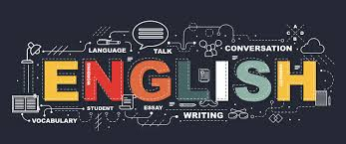
We will be using set texts The Iron Man and Fox. We will be working on improving our reading and comprehension skills, through daily guided reading sessions.
In writing, we will be working on spelling, grammar and punctuation. Handwriting will be a focus and we expect children will begin to join letters correctly, when ready. In English, we will be using books with handwriting line guides to assist the children in improving their handwriting.
Reading

All children will be expected to read each night at home. (I recommend at least 10 minutes per night.) Reading scheme books will be brought home each night. In Year 3, the children begin to change their own books when they arrive in school in the morning. Encourage your child to do this to promote greater independence. Please make sure you record what they have read in their reading record book each night. It is essential that this is brought to school each day. We will collect them in regularly to monitor home reading.


Maths
We will be concentrating on Place value, Calculations, Problem solving, Shape and Data Handling. Children will also spend time working on mental calculations and complete weekly arithmetic tasks for practise.
The children will learn times tables using our Times Tables Challenge Scheme. We will do this each Friday and if children are unable to complete their sheet within the allocated time then it will be sent home to enable them to practise. In addition to this, we will use Mathsframe Multiplication Check which children can access at home. (We use this every Thursday morning so should be able to Google and complete at home too) Our aim is for all children to know 2, 5, 10, 3, 4, 8, 9 and 11 times tables facts by the end of Year 3.


Topics for this term
Our topics for the term are No Place Like Home and Healthy Humans.

These topics are linked to curriculum subjects in the following way:
Science – Healthy Humans / Light and Dark
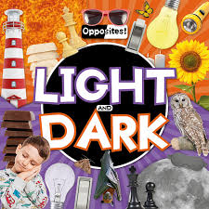
ICT – Computer systems and networks / Branching data bases / E-Safety
RE – Harvest / Christmas God with us

Geography – Our Local Area
PE – Gymnastic / Invasion games
History – Local Area in the past / History of our school
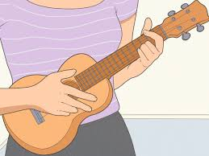
Music – Introduction to Ukulele
Art / DT – Drawing & Shading skills / Food for a purpose
PSHE – My Happy Mind – Meet Your Brain / Celebrate Character strengths – Friendships / Mental health and wellbeing.
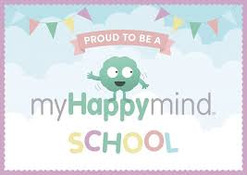
Homework
Children will receive on piece of homework each week on Tuesday, alternating an English or Maths focus. This will be due in for the following Monday.
I am encouraging children to focus on handwriting and times tables, in addition to reading. Spellings will continue to be sent home.
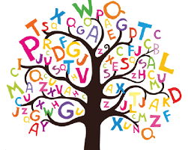
Friday – Spellings (to be tested the following Friday)
Please let me know if your child finds anything particularly challenging as all work set will be related to what we are covering in class so should be revision or practise for your child.
PE
We will do PE on Wednesday afternoons and Friday afternoons.

Please ensure that earrings are removed at home on a PE day. In addition to standard PE kit (t-shirt, shorts and pumps) all children will need to have trainers in school in order to go outside if the weather is suitable.

Staff in Year 3
Mrs Plum will be our Teaching Assistant this year. She will be working in Year 3 to support groups of children and delivering lessons some afternoons during the week.
The children will also have Mr Norton from the Lancashire Music Service teaching Ukulele on a Wednesday.
I hope your child will have an enjoyable and happy time in Year 3.
Please remember if you have any worries or concerns make a note in your child’s reading record or contact the office to make a telephone appointment and I will get back to you as soon as possible.
Many thanks for your support.
Mrs Sarah Watson

