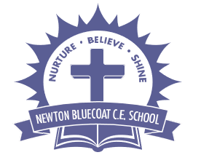
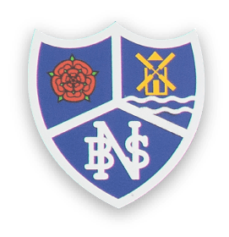
Year 1 Class Letter
Autumn Term 2026
Welcome to Year One!
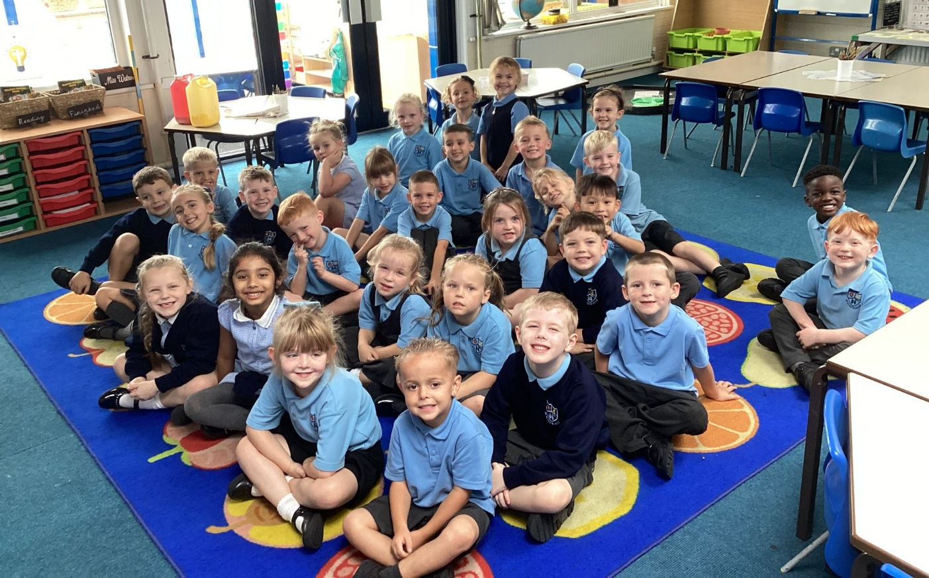

We have made a brilliant start to Year 1 embracing the new Year 1 routine. Alongside getting stuck in with our Maths, Phonics and English, we have started our topic My family and Me and got to know our new classroom and routines! We have lots more learning to get stuck into next week!

On Friday we had a busy morning with our first practice Year 1 spelling and arithmetic test, finishing off with a fun Friday afternoon golden time and reading to Miss Watson!

Well done Year 1 a fantastic start!

Our topic for this term is: My Family and Me!

English

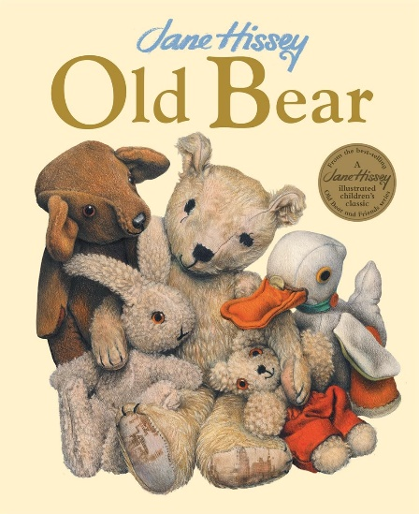
We have a brand new English scheme that we are implementing this term that is both hands on as well as focusing on reading, writing, SPaG and building vocabulary. We will focus on a different book every term / half term and lots of our provision and activities will be based around this. This term our book is: Old Bear.

After half term our book will be: Rapunzel.

We also share stories in class every day from our class collection.

Reading books are sent home on a Monday and Thursday and a phonics activity on Tuesday. Your child will bring home a book closely matched to their phonic ability. Please allow time to listen to your child read, many of our new reading books have prompts for parents to help you as you read together with your child. If your book is finished please sign the diary and your child will pop it in the finished basket for it to be changed. If you are still reading it will be returned to finish off.

Maths
This term we will be focusing on Place Value, Addition and Subtraction and shape. We are continuing with the White Rose Maths scheme and building on the skills and Maths Mastery the children have developed in Reception. Maths in Year 1 is both practical as well as written whole class/ group work and extra challenges in provision. We will soon begin to learn our times tables too!

Phonics
This half term we will be revisiting Phase 4 consonant blends and consolidating our learning from Reception before we move onto Phase 5. Reading books closely linked to your child’s phonic ability we be sent from next week. We want to get settled and have some fun first!

Homework
Maths / English homework will be sent on a Friday to be returned by the following Wednesday as well as weekly spellings to be learnt for the following Friday. A Phonics activity/book based on our learning that week will be sent on a Tuesday.

PE
Our PE sessions will vary each term so please ensure your child always has their named kit in school. This term we will be doing PE on a Monday/Tuesday. A pair of trainers is also helpful for when we are outside or if they wish to participate in organised sporting activities at lunchtime. Please be aware we are very low on spare PE kits, so if your child does not bring theirs, we cannot guarantee they will be able to participate.
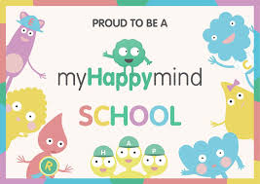

PSHE
We are continuing our PSHE curriculum ‘Our Happy Minds’. It programme that prepares today's children for tomorrow's world by building resilient, balanced and happy minds. We aim to create a culture of positive mental wellbeing! We also do focused lessons from the PSHE association building skills such as resilience, self-esteem, life skills, risk-management, and teamworking.

Topic
This term our topic focus will be My Family and Me. For our first lesson we have looked at our birthdays and put up our class time line. We are going to look at our family trees and changes over time so it would be great if you could send a family photo into school in a named envelope for next week.

RE
Our first topic for RE is Harvest. We are going to collect store cupboard goods for our harvest collection, contributions are greatly appreciated. We will be looking at food from all around the world and tasting and trying foods from different cultures and places. If you would like to bring something for our children to taste from a different cultural background that would be wonderful! Our tasting lesson will be on Tuesday 15th September.

Teaching Assistants
Mrs Razvi will be working as a Teaching Assistant in our class Monday to Friday and Mrs Cartwright will be teaching Art / DT and Music on Wednesday afternoons.

Water Bottles
Please ensure your child has a named water bottle in school. These will be sent home each week for washing and refilling.

Health Care Plans
If your child has a health care plan, any allergies or special requirements please ensure they are up to date with the office. All medicines/inhalers need to be checked and made sure they are in date. Thanks!

We have a ‘Meet the Teacher’ session afterschool on Monday 14th September from 3:30 – 4:30 if you would like to pop and meet me, have a chat or ask any questions!

If you have any questions, worries or concerns please ring the office and leave a message, or make a note in your child’s reading diary. I will get back to you as soon as possible.

As always I will be available at home time for a chat at the gates if you need me!

Many thanks for your continued support.
We look forward to an exciting, hands on and fun filled year 1!

Miss Watson
&
Mrs Razvi

