 |  | Year: |  | 1/2 | Unit: | What has changed since my  grandparents were young?
What will I learn this year?
- Develop an awareness of the past, using common words and phrases relating to the passing of time.
- They should use a wide vocabulary of everyday historical terms.
- They should know where the people and events they study fit within a chronological framework and identify similarities and differences between ways of life in different periods.
National Curriculum - History
- Pupils should be taught about changes within living memory. Where appropriate, these should be used to reveal aspects of change in national life.
National Curriculum links to other subjects DT
Key Vocabulary |  |  |  |  | What should I already know?
change | When things don’t stay the same. |  | Grandparents toys  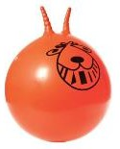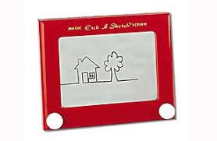  Parents toys  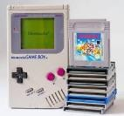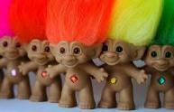  Your toys  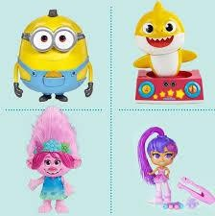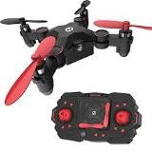 |  | - I know we play with toys, but the toys our grandparents played with may have been different to  those we play with today.
different | Things that are not the same. |  |  |  | - I have memories from my own past about the toys I played with.
si milar | Things that are the same. |  |  |  | 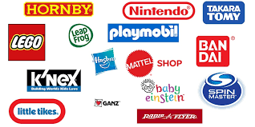
old | Something that has existed for a long time.
past | Something that has already happened.
present | The time right now. |  |  |  | What will I learn next?
new | Something that has not existed for a long time. |  |  |  | - I will learn to recognise differences and similarities between toys in the past and toys in the present.
me mory | Things that people can recall or remember about the past. |  |  |  | - I can describe some changes in that have happened in living memory.

chronological | In order of when it happened. |  | - I can order and sequence events and artefacts from  the oldest to the newest.
Compare | To identify what is the same and what is different. |  | - I can retell simple events from the past. towneleyhall@burnley.gov.uk

