 |  | Year: |  | Year 5 / 6 | Unit: |  | Were the Vikings vicious and  always victorious?
What will I learn this year?
- Learn how Britain has been influenced by the wider world.
- To identify trends and contrasts over time.
- Make links between and across periods, such as the differences between clothes, food buildings or transport.
Key Vocabulary |  |  |  |  |  | What should I already know?
Chieftain | The leader of a village or small group of  people. |  | The first Viking raid was at Lindisfarne in 793AD  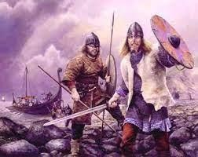  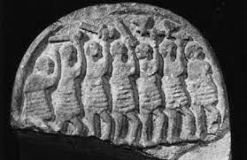  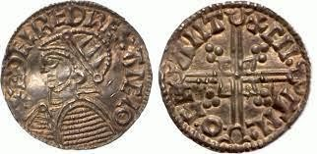  The Danegeld: Money paid by the Saxons to the Vikings to stop their land being raided.  The Danelaw:  Land controlled by the Vikings.  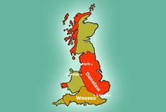 |  |  | - I should already know the terms BC, AD, BCE, CE
Freeman | A person who is not a slave and can choose who he or she worked for. |  |  |  |  | - I should have used evidence from primary and secondary sources to make historical claims.
Longship | A long flat bottomed Viking ship with a large  square sail and oars. |  |  |  |  | - I should have some understanding of previous invaders of Britain and their influence.
Runes | The name given to the Viking alphabet. |  |  |  |  | 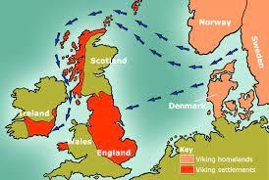  The Vikings came from Scandinavia. They raided at first before eventually settling in the country.
Thatched | A roof covered in straw.
Trader | A person who buys and sells goods. |  |  |  |  | What will I learn next?
Scandinavia | Is the name given to the three kingdoms of Denmark, Sweden and Norway. |  |  |  |  | - I will learn about Viking raids, invasion and settlements.
Figurehead | A carving at the prow of a boat. Many Viking ships had dragon carvings. |  |  |  |  | - I will learn about resistance by Alfred the Great and Athelstan, first king of England.
Colonise | Send settlers to take control of an area |  |  |  |  | - I will learn about the Danegeld.
Settler | A person who moves with a group of other people to live in a new country or area. |  |  |  |  | - I will learn about the end of Viking and Anglo-Saxon rule in England.

