 | Year: | Year 3/4 | Unit: | Who First Lived in Britain?
What will I learn this year?
- Use specialist dates and terms, and by placing topics studied into different periods.
- Make some links between and across periods, such as the differences between clothes, food, buildings or transport.
- Understand some significant aspects of history.
- Construct informed responses that involve thoughtful selection and organisation of relevant historical information
- Understand some of the methods of historical enquiry, how evidence is used to make historical claims.
National Curriculum – History
Pupils should be taught about changes in Britain from the Stone Age to the Iron Age Examples (non-statutory) This could include:
- late Neolithic hunter-gatherers and early farmers, for example, Skara Brae
- Bronze Age religion, technology and travel, for example, Stonehenge
- Iron Age hill forts: tribal kingdoms, farming, art and culture
National Curriculum links to other subjects
Art - To improve their mastery of art and design techniques, including drawing, painting and sculpture with a range of materials [for example, pencil, charcoal, paint, clay]

Key Vocabulary |  | 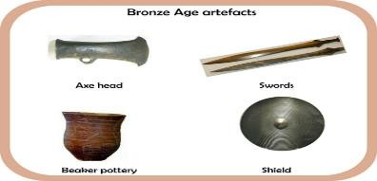  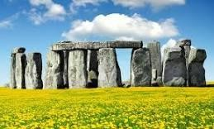  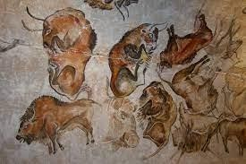 |  | What should I already know?
Palaeolithic | The old stone age |  |  | - I can use common words and phrases relating to the passing of time.
Mesolithic | The middle stone age |  |  | - I can use parts of stories and other sources to show that they know and understand key features of events.
Neolithic | The new stone age |  |  | - I understand some of the ways in which we find out about the past
artefacts | Objects of historical significance. |  |  | Sticky Learning  Sticky Knowledge about the Stone Age Period
archaeologist | A person who studies human and prehistory history through the excavation of sites and the analysis of artefacts and other physical  remains. |  |  | - The stone-age period is said to have started around 3 million year ago when humans started to live in Europe.
source | A book or document used to provide evidence in research. |  |  | - The stone-age was followed by the bronze-age period. This is when humans started to use metal.
chronological | A record of events following the order in which they occurred. |  |  | - The bronze-age was followed by the iron-age when tools and weapons became more advanced and were used for farming.
prehistory | The period of time before written records. |  |  | - During the Palaeolithic Age (old stone age), man gathered food by hunting wild animals and birds, fishing, and collecting fruits and nuts.
settlements | A place where people establish a village or town. |  |  | - During the Neolithic Age (towards end of the stone-age), the humans formed settled communities, and domesticated plants and animals for the first time in history.
foraging | Gather (food or provisions) by searching.
IMPORTANT | Skara Brae - Is an archaeological site found on the Orkney Islands in Scotland. It is a stone age village that has been well preserved. |  | Stonehenge - Is a famous stone age monument in Wiltshire.

** For teachers planning
History - End of Year Expectations

 | Chronology |  | Events, People and Changes | Interpretation, Enquiry and Using Sources |  | Communication
Year 4 | ⯈  ⯈  ⯈ | Use dates and historical terms when ordering events and objects.  Identify where people and events fit into a chronological framework.  Explore links and contrasts within and across different periods of time. | ⯈ Describe and compare some of the characteristic features and achievements of the earliest civilisations including where and when they appeared.  ⯈ Demonstrate more in-depth knowledge of one specific civilisation e.g. Ancient Egypt.  ⯈ Demonstrate knowledge of an aspect or theme in British History that extends their chronological knowledge beyond 1066. | ⯈  ⯈  ⯈  ⯈ | Use sources to address historically valid questions and hypotheses.  Recognise how sources of evidence are used to make historical claims.  Recognise why some events happened and what happened as a result.  Identify historically significant people and events in different situations. | ⯈  ⯈  ⯈ | Discuss significant aspects of, and connections between, different historical events.  Select and organise relevant historical information to present in a range of ways. Use relevant and appropriate historical terms and vocabulary linked to chronology.
Year 3 | ⯈  ⯈  ⯈ | Use some dates and historical terms when ordering events and objects.  Demonstrate awareness that the past can be divided into different periods of time. Explore trends and changes over time. | ⯈ Describe and give reasons for some of the changes in Britain from the Stone Age to the Iron Age.  ⯈ Describe some aspects of the Roman Empire and recognise its impact on Britain.  ⯈ Demonstrate knowledge of aspects of history significant in their locality. | ⯈  ⯈  ⯈  ⯈ | Use sources to address historically valid questions.  Recognise that our knowledge of the past is constructed from different sources of evidence.  Recognise that different versions of past events may exist.  Describe some of the ways the past can be represented. | ⯈  ⯈  ⯈ | Discuss some historical events, issues, connections and changes.  Select and organise historical information to present in a range of ways.  Use relevant historical terms and vocabulary linked to chronology.

Word Aware Vocabulary to be taught directly |  |  | 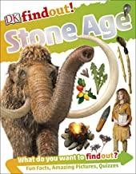  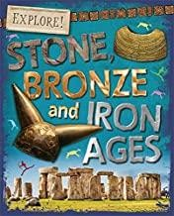  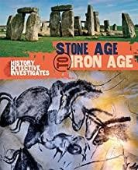  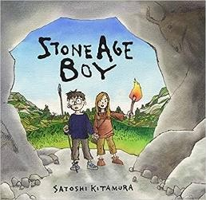  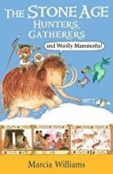  Recommended Reads
May cross over depending on year group and previous experiences
Tier 1 | Tier 2 | Tier 3

