 |  | Year: |  | Year 3/4 | Unit: |  | Were the Romans rotten and  what did we learn from them?
What will I learn this year?
- Place periods of history on a timeline.
- Use specialist dates and terms. ( BC, AD, CE, BCE, century, millennium, Roman, invasion)
- Learn how Britain became part of the Roman Empire.
Key Vocabulary |  |  |  |  |  | What should I already know?
Emperor | The male ruler of an empire |  | Sticky Knowledge about the Romans  - Julius Caesar was the best-known Roman leader. He created the Julian Calendar, which is what the calendar we use today is based on.  - The Romans invaded and conquered many countries in Europe before heading to Britain.  - Boudicca was a queen of the British Celtic Iceni tribe who led an uprising against Roman occupied towns and cities.  - The Romans left their mark on Britain leaving us new towns, plants, animals, religion, and ways of reading and counting.  - Hadrian’s Wall – A long wall built by the Romans across the north of England. It was built to keep immigrate out the Scots.  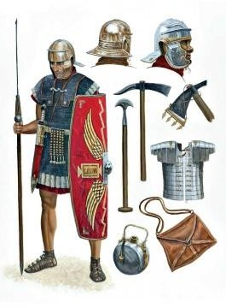  A Roman Legionnarie |  |  | - I should already know the terms BC, AD, BCE, CE
Empire | A group of nations or peoples under one ruler or government. |  |  |  |  | - Understand some methods of historical enquiry.
Legionnaire | A member of a legion. |  |  |  |  | - I know how the past can be represented in different ways.
Legion | An army unit in ancient Rome that was made up of soldiers on foot and on horseback. |  |  |  |  | 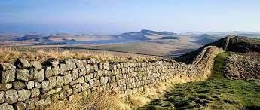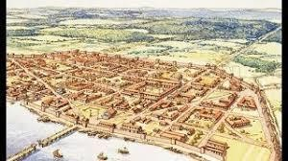  Hadrian’s Wall built in 122 AD Londinium (London)
Invade | To enter as an enemy, by force, in order to conquer.
Conquer | To get or overcome by force. |  |  |  |  | What will I learn next?
Emigrate | To leave one country or region in order to settle in another. |  |  |  |  | - I will understand how Britain was influenced by Rome.
Immigrate | To come to live permanently in a country where one was not born. |  |  |  |  | - I will learn about the lives of people in Roman Britain.
Gladiator | A man in ancient Rome who fought other  men or animals, often to the death, to entertain an audience. |  |  |  |  | - I will make links between peoples of different periods.
Architecture | The style or way of building. |  |  |  |  | Romans in Lancashire: https://ribchesterromanmuseum.org/

