 |  | Year: |  | Year 5/6 | Unit: |  | Who were the Maya and what have we learnt from them?
What will I learn this year?
- Learn about a non-European society that provides contrasts with British history – Mayan civilisation C. AD 900
- Understand the characteristic features of a non-European society.
- Form a narrative showing connections and trends within and across periods studied.
- Sequence events and periods through the use of appropriate terms relating to the passing of time
National Curriculum - History
A non-European society that provides contrasts with British history - Mayan civilization c. AD 900
National Curriculum links to other subjects
Maths, RE. Art museums.education@lancashire.gov.uk outreach services available
Key Vocabulary |  |  |  |  |  | What should I already know?
calendar | A printed table showing all the days, weeks, and months of the year. |  | Mayan number system  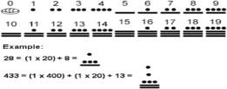  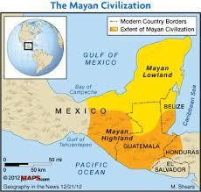  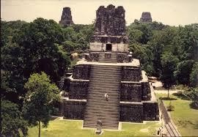  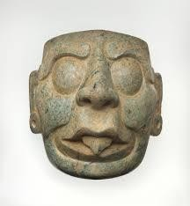 |  |  | - I should be able to identify the location of the Maya area.
dynasty | A series of rulers or leaders who are all from the same family, or a period when a country is ruled by them. |  |  |  |  | - I should have used sources as a basis for research.
empire | A group of countries ruled by a single person, government, or country. |  |  |  |  | - I should understand some important time vocabulary and be able to locate periods on a timeline.
rituals | A religious or solemn ceremony consisting of a series of actions performed according to a prescribed order. |  |  |  |  | - I should be aware of different versions of past events.
sacrifice | An act of slaughtering an animal or person as an offering to a god or gods.
civilisation | Human society which is organised. |  |  |  |  | What will I learn next?
hieroglyphics | A system of writing using pictures not words. |  |  |  |  | - I will learn how the Mayan Empire was organised around city- states.
Class society | A system of ordering society whereby people are divided into sets based on perceived social or economic status. |  |  |  |  | - I will learn about Mayan culture including, their writing and number system, art and the development of a calendar.
Creation story | The creating of the universe, especially when regarded as an act of God. |  |  |  |  | - I will learn about their beliefs and significant gods.
currency | A system of money in general use in a particular country. |  |  |  |  | - I will learn how to evaluate sources and contrast arguments and interpretations.

Word Aware Vocabulary to be taught directly |  |  | Sticky Knowledge
May cross over depending on year group and previous experiences |  |  | The Mayans were excellent mathematicians and astronomers. They used this expertise to make calendars.
Tier 1 | Tier 2 | Tier 3 | Although the Mayans had metal-working skills, metal ores were scarce. Mayans used stone tools to carve the limestone that they used for their buildings.
calendar  create → creation → creator | Archaeology → archaeologist Astronomy → astronomer | hieroglyphics glyphs | Mayan religion was extremely bloodthirsty, demanding human sacrifices and blood-letting rituals. The Mayans believed in an afterlife and that those who were sacrificed, as well as those killed in war
numeral | Ritual solar sacrifice  civilization scholar dynasty | codex  codices | and women who died in childbirth, went to ‘the place of misty sky’.
Class society
Empire rituals currency
 | Class society  Empire rituals currency |  | At the top of Mayan society was the King and Royal family who were believed to be closely linked to the gods. An educated elite of scribes, priests and nobles formed the ruling class. They occupied the
 |  |  | finest buildings in the city.
 |  |  | Mayan society was formed of a number of city states each with their own ruler.
Recommended Reads

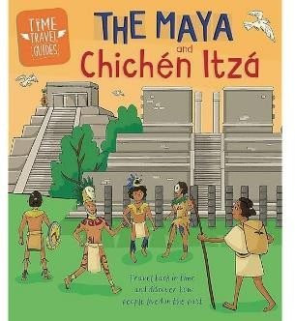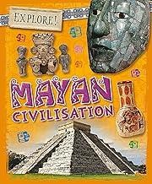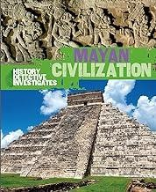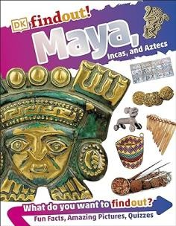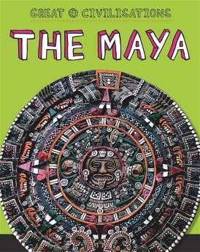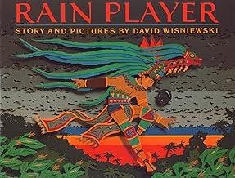

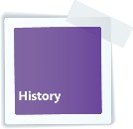
Key Learning in History: Years 5 and 6

Chronology | Events, People and Changes |  | Communication
Show their chronologically secure knowledge by:  - Sequencing events and periods through the use of appropriate terms relating to the passing of time (empire, civilisation, parliament, peasantry...).  - Identifying where periods studied fit into a chronological framework by noting connections, trends and contrasts over time.  - Know and understand the history of these islands as a coherent, chronological narrative, from the earliest times to the present day.  - In depth study of different periods, using appropriate vocabulary when describing the passing of time and historical concepts (propaganda, bias, primary source, secondary source, reliability...).  - Analyse connections, trends and contrasts over time. | Show their knowledge and understanding of local, national and international history by:  - Understanding significant aspects of history – nature of ancient civilisations; expansion and dissolution of empires; characteristic features of non-European societies; achievements and follies of mankind.  - Gaining historical perspective by placing their growing knowledge into different contexts...between cultural, economic, military, political religious and social history.  - Establishing a narrative showing connections and trends within and across periods of study.  - Begin to recognise and describe the nature and extent of diversity, change and continuity and suggest relationships between causes.  - Presenting a clear narrative within and across periods that notes connections, contrasts and trends over time. |  | - Produce structured work that makes connections, draws contrasts, analyses trends, frames historically-valid questions involving thoughtful selection and organisation of relevant historical information using appropriate dates and terms.  - Produce detailed structured work to select and deploy information and make appropriate use of historical terminology and contrasting evidence.
Enquiry, Interpretation and Using Sources
- Understand the methods of historical enquiry, how evidence is used to make historical claims, and begin to discern how and why contrasting arguments and interpretations of the past have been constructed.  - Use sources as a basis for research from which they will begin to use information as evidence to test hypotheses.  - Begin to evaluate sources to make historical claims, and discern how and why contrasting arguments and interpretations of the past have been constructed, and establish evidence for particular enquiries. |  | - Understand how our knowledge of the past is constructed from a range of different sources and that different versions of past events often exist, giving some reasons for this.  - Begin to recognise why some events, people and changes might be judged as more historically significant than others.

5
6

History - End of Year Expectations

Year 6 | ⯈ Use dates and a wide range of historical  terms when sequencing events and periods of time.  ⯈ Develop chronologically secure knowledge of  the events and periods of time studied.  ⯈ Analyse links and contrasts within and across different periods of time including short-term and long-term time scales.  Week 1  Week 2  Week 3  Week 4  Week 5  Week 6 | ⯈ Describe aspects of the Viking and Anglo-  Saxon struggle for the Kingdom of England in the time of Edward the Confessor.  ⯈ Demonstrate knowledge of an aspect or  theme in British history that extends their chronological knowledge beyond 1066. | ⯈ Regularly address and sometimes devise  historically valid questions and hypotheses.  ⯈ Give some reasons for contrasting arguments and interpretations of the past.  ⯈ Describe the impact of historical events and  changes.  ⯈ Recognise that some events, people and changes are judged as more significant than others. | ⯈ Acknowledge contrasting evidence and  opinions when discussing and debating historical issues.  ⯈ Use appropriate vocabulary when discussing,  describing and explaining historical events.  ⯈ Construct informed responses to historical questions and hypotheses that involve thoughtful selection and organisation of relevant historical information including appropriate dates and terms.  ⯈ Choose the most appropriate way of  communicating different historical findings.
Year 5 | ⯈ Use dates and appropriate historical terms to  sequence events and periods of time.  ⯈ Identify where people, places and periods of time fit into a chronological framework.  ⯈ Describe links and contrasts within and  across different periods of time including short-term and long-term time scales. | ⯈ Describe some aspects of Britain’s  settlement by Anglo-Saxons and Scots.  ⯈ Demonstrate knowledge of Ancient Greece  including Greek life and achievements and their influence on the western world.  ⯈ Describe key aspects of a non-European  society such as the early Islamic civilisation. | ⯈ Use a wider range of sources as a basis for  research to answer questions and to test hypotheses.  ⯈ Recognise how our knowledge of the past is  constructed from a range of sources.  ⯈ Evaluate sources and make simple inferences.  ⯈ Choose relevant sources of evidence to support particular lines of enquiry. | ⯈ Discuss and debate historical issues.  ⯈ Use appropriate vocabulary when discussing and describing historical events.  ⯈ Construct responses to historical questions and hypotheses that involve selection and organisation of relevant historical information including dates and terms.  ⯈ Choose relevant ways to communicate historical findings.

