 |  | Year: |  | Year 5/6 | Unit: |  | How did the Industrial  Revolution shape the Burnley we see today?
What will I learn?

Learn what life was like before the Industrial Revolution
Understand the term Industrial Revolution and that it happened over a long period of time but quickly in terms of our wider historical timeline.
Explain the main causes of the Industrial Revolution
Learn what it was like to work to in a mine / mill as a child in Victorian times. Learn how industry has changed from the Victorian times to the present day.
Learn how Burnley changed as a result of the Industrial Revolution

National Curriculum - History

- To study an aspect of history or a site dating from a period beyond 1066 that is significant in the locality.
- To study an aspect or theme in British history that extends pupils’ chronological knowledge beyond 1066
- A significant turning point in British history, for example, the impact of the Industrial Revolution.
Key Vocabulary |  |  |  |  |  | What should I already know?
mill | A building that contains spinning and  weaving machinery to make cloth |  | Views of Burnley  Weaver’s Triangle C. 1910  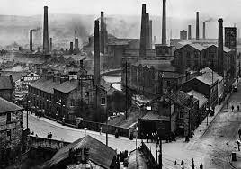  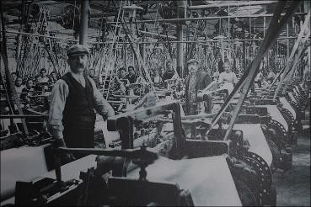  A typical Weaving shed full of looms. |  |  | I should be able to identify human features on a map using  a key.
shed | A single storey mill developed in the  1800s in Lancashire. |  |  |  |  | I should have used evidence from primary and secondary  sources to make historical claims.
export | Sell goods to another country. |  |  |  |  | I should have learnt about the triangular slave trade.
import | Buy goods from another country. |  |  |  |  | I should understand the terms local, regional, national and international.
loom | Machine used to make cloth by weaving yarn and thread. |  |  |  |  | Use research skills to explain how Britain has changed
famine | Extreme scarcity of food. |  |  |  |  | Plot events from the Stone Age to the end of the Vikings occupation on a timeline
shuttle | A bobbin with two pointed ends designed  to carry thread in the process of weaving on a loom. |  |  |  |  | Explain that the way the kingdoms were divided led to the creation of some of our count boundaries today

revolution | A massive change in conditions, attitudes or operations | Key knowledge for Burnley  The arrival of the Leeds and Liverpool Canal in 1796 made possible transportation of goods in bulk, bringing a huge boost to the area's economy and the town of Burnley was born.  Dozens of new mills were constructed, along with many foundries and ironworks that supplied the cotton mills and coal mines with machinery.  The town became renowned for its mill-engines, and the Burnley Loom was recognised as one of the best in the world.  By 1830, there were 32 steam engines in cotton mills throughout the rapidly expanding Burnley, an example of which, originally installed at Queen Street Mill, Harle Syke, is on display in the Science Museum in London. | Sticky Learning  Sticky Knowledge about the Industrial Revolution
industrial | Types of work such as manufacturing and mineral extraction and areas such as warehousing and docks |  | The Industrial Revolution began in 1760
plantation | A large estate on which crops such as coffee, sugar, and tobacco are grown. |  | Before the Industrial Revolution, the population was 11 million, 80% of the population lived in the countryside; most things were produced by hand within the family homes and the main form of transport was the horse and cart.
Key People  Charles Dickens – Victorian writer  Titus Salt – Mill owner and philanthropist  George Stephenson - an inventor and engineer, inventor of the Rocket, a steam engine which won a competition to pull carriages along a rail track.  James Watt - invented an improved steam engine which could be used to power mill machinery  Queen Victoria - the Queen of Great Britain and the British Empire during much of time known as the Industrial Revolution. |  |  | The 6 factors that led to the Industrial Revolution were: population boom, improved agriculture, new forms of power, building of factories, improved transport and expansion of the British Empire.
 |  |  | That education for children was practically non-existent and that children had to go to work as early as 5 years old.
 |  |  | Conditions in the mines and factories were dangerous with little thought of health and safety measures.
During the Industrial Revolution Burnley became one of Lancashire's most prominent mill towns; at its peak, it was one of the world's largest producers of cotton cloth and a
major centre of engineering.

Word Aware Vocabulary to be taught directly |  |  | Recommended Books  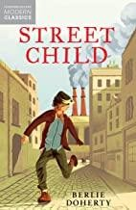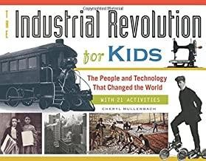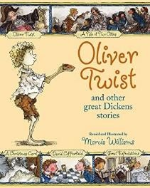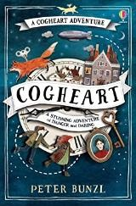
May cross over depending on year group and
previous experiences
Tier 1 | Tier 2 | Tier 3
To be added when planning individual lessons

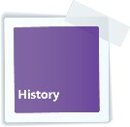
Key Learning in History: Years 5 and 6

Chronology | Events, People and Changes |  | Communication
Show their chronologically secure knowledge by:  - Sequencing events and periods through the use of appropriate terms relating to the passing of time (empire, civilisation, parliament, peasantry...).  - Identifying where periods studied fit into a chronological framework by noting connections, trends and contrasts over time.  - Know and understand the history of these islands as a coherent, chronological narrative, from the earliest times to the present day.  - In depth study of different periods, using appropriate vocabulary when describing the passing of time and historical concepts (propaganda, bias, primary source, secondary source, reliability...).  - Analyse connections, trends and contrasts over time. | Show their knowledge and understanding of local, national and international history by:  - Understanding significant aspects of history – nature of ancient civilisations; expansion and dissolution of empires; characteristic features of non-European societies; achievements and follies of mankind.  - Gaining historical perspective by placing their growin g  knowledge into different contexts...between cultural, economic, military, political religious and social history.  - Establishing a narrative showing connections and trends within and across periods of study.  - Begin to recognise and describe the nature and extent of diversity, change and continuity and suggest relationships between causes.  - Presenting a clear narrative within and across periods that notes connections, contrasts and trends over time. |  | - Produce structured work that makes connections, draws  contrasts, analyses trends, frames historically-valid questions involving thoughtful selection and organisation of relevant  historical information using appropriate dates and terms.  - Produce detailed structured work to select and deploy  information and make appropriate use of historical terminology and contrasting evidence.  Week 1  Week 2  Week 3  Week 4  Week 5  Week 6  Throughout the unit
Enquiry, Interpretation and Using Sources
- Understand the methods of historical enquiry, how evidence is used to make historical claims, and begin to discern how and why contrasting arguments and interpretations of the past have been constructed.  - Use sources as a basis for research from which they will begin to use information as evidence to test hypotheses.  - Begin to evaluate sources to make historical claims, and discern how and why contrasting arguments and interpretations of the past have been constructed, and establish evidence for particular enquiries. |  | - Understand how our knowledge of the past is constructed from a range of different sources and that different versions of past events often exist, giving some reasons for this.  - Begin to recognise why some events, people and changes might be judged as more historically significant than others.

5
6

