 |  | Year: |  | 1/2 | Unit: |  | You and Whose Army?
What will I learn this year?
- Develop an awareness of the past, using common words and phrases relating to the passing of time.
- Use a wide vocabulary of everyday historical terms.
- Know where the people and events they study fit within a chronological framework.
- Ask and answer questions, choosing and using parts of stories and other sources to show that they understand the key features of events.
Key Vocabulary |  |  |  |  |  | What should I already know?
source | Something that shows  information about the past. |  | Samuel Pepys  Pepys wrote a diary which is how we know so much about the fire.  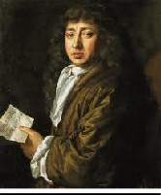  King Charles II - King from 1660 -1685  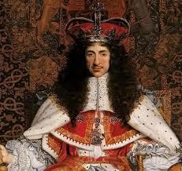  Tower of London –  Where King Charles II lived in 1666. It was not damaged by the fire.  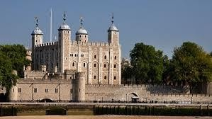  St Paul’s Cathedral –  Famous cathedral that burnt down during the fire.  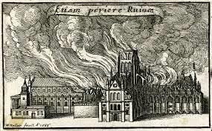 |  |  | - I can use time vocabulary in my answers.
thatched roof | Dried straw tied tightly together  and laid on a roof of a building. |  |  |  |  | - I can recognise similarities and differences between the present and the past.
wattle and  daub | Animal waste, straw and mud  used to make walls of buildings. |  |  |  |  | - I can retell simple events from the past.
timber frame | Wooden frame of a building. |  |  |  |  | - I can put artefacts in chronological order.
cathedral | Main church for a diocese.
government | Group of people who rule a  country. |  |  |  |  | What will I learn next?
reliable | Can be trusted. |  |  |  |  | - Use a wider vocabulary of historical terms.
timeline | The order in which events  happen. |  |  |  |  | - Understand a significant national event beyond living memory.
embers | Burning remains of a fire. |  |  |  |  | - Use sources and stories to understand the events.
Main Events  2nd September 1666 1:30am: a fire starts in  Thomas Farriner’s bakery on Pudding Lane.  2nd September 1666 7am: Samuel Pepys wakes up and finds out that the fire had already burnt down 300 houses!  3rd September1666: The firemen try to put the fire out using leather buckets of water and then pulling down houses with fire hooks.  4th September 1666: St. Paul’s Cathedral burns  down.  6th September 1666: The Fire of London finally stops but many people are left homeless. |  |  |  |  |  | - Sequence events.  Pudding Lane - The street where the fire started  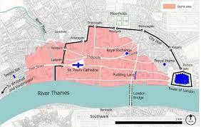  River Thames - The river that runs through London where many people escaped to avoid the fires.  

