 |  | Year: |  | Year 5/6 | Unit: |  | Rules, Rights and  Responsibilities
What will I learn this year?
- Show their knowledge and understanding of local, national and international history.
- Begin to recognise and describe the nature and extent of diversity, change and continuity and suggest relationships between causes.
- Analyse connections, trends and contrasts over time.
- Begin to recognise why some events, people and changes might be judged as more historically significant than others.
Key Vocabulary |  |  |  |  |  | What should I already know?
apartheid | A policy or system of segregation or discrimination on grounds of race used in South Africa from 1948 -1994. |  | 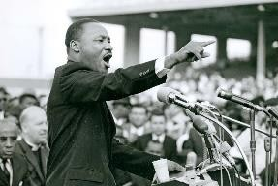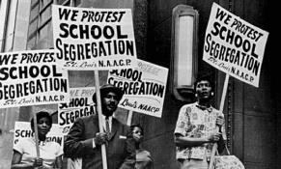  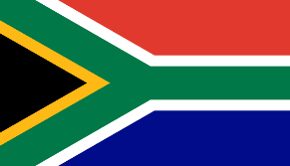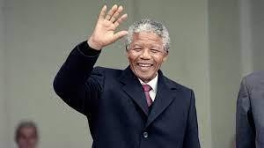  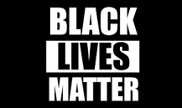 |  |  | I understand some of the methods of finding out about the past.
civil disobedience | Peacefully refusing to follow laws or commands that you feel are unfair. |  |  |  |  | I have an understanding of some significant aspects of history. i.e. Slavery and Britain’s part in the Slave Triangle and the impact this had on the USA from my  studies in year 3/4.
civil rights | Rights that protect your ability to participate in the civil and political life of a country without discrimination. |  |  |  |  | I know about the American Civil War 1861 – 65 through my studies of Harriet Tubman.
discrimination | The unjust or prejudicial treatment of different categories of people. |  |  |  |  | I Know about the impact of Rosa Parks in the Civil Rights movement from my studies in year 1/ 2.
segregation | Separating different groups of people.
Separate but equal | The act of different, but equal, facilities to different groups of people. |  |  |  |  | What will I learn next?
boycott | The act of stopping using a company or service in protest of something they are doing. |  |  |  |  | I will learn how modern day America still contains inequalities for non – white Americans and the significance and impact of the Black Lives Matter  campaign.
Jim Crow Laws | A series of laws in the southern states of the USA which discriminated against black people. |  |  |  |  | I will learn how the apartheid system was adopted in South Africa and how Nelson Mandela was imprisoned for protesting against the apartheid system before becoming the first black President of South Africa.
nonviolence | To act not using violence under any circumstances. |  |  |  |  | I will learn about Martin Luther King and his impact in changing American society in the 1960s.

