 |  | Year: |  | Year 1/2 | Unit: |  | Rules, Rights and  Responsibilities
What will I learn this year?
- Recognising the distinction between present and past in their own and other people’s lives.
- Know where some people and events fit into a chronological framework by using common words and phrases
about the passing of time. (before, after a long time ago, past…)
- To tell the difference between past and present in their own and other people’s lives.
- To begin to understand the reasons why people in the past acted as they did from a range of sources (pictures, plays, films, written accounts, songs, museum displays, stories).
National Curriculum - History
  - Pupils should be taught the lives of significant individuals in the past who have contributed to national and international achievements..
National Curriculum links to other subjects PSHE and Citizenship
Key Vocabulary |  |  |  |  |  | What should I already know?
boycott | Refusing to take part in something. |  | Rosa Parks Timeline  1913 1stDecember 5th December 2005  1955 December 1955-  1955 December1956  Rosa Rosa Parks Rosa The bus Rosa Parks was told Parks boycott took parks was born to give up was place. Black died on in her seat on charged people the 4thof Alabama, the bus for with showed their December.  USA on a white breaking support for the 4thof person but the Rosa, by February. she rules. refusing to  refused. She was use the found buses. The  guilty boycott lasted  and for 381 days. charged.  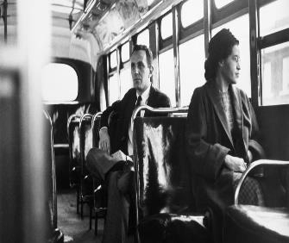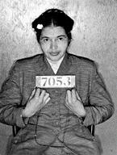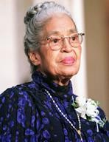 |  |  | - I can tell between past and present.
Alabama | A state in America. |  |  |  |  | - I have used stories to learn about the past.
comply | Follow a command. |  |  |  |  | - I can study pictures and read writing to answer simple questions about the past.
arrested | Taken into custody. |  |  |  |  | - I Know that we live in a multiracial society.
custody | Taken into police imprisonment
protest | When people show that they are against something. |  |  |  |  | What will I learn next?
Refuse | Choose not to follow a command. |  |  |  |  | - I will learn how Rosa Parks stood up to racial injustice by peaceful protest and succeeded to change the laws.
fined | A fee which must be paid for breaking the rules. |  |  |  |  | - I will become aware of black history and how people of African dissent were enslaved and taken to the USA from  Africa on British slave ships.
seemstress | Awomen who sews for a living.

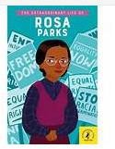
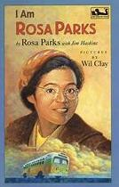
Exciting books about Rosa Parks

