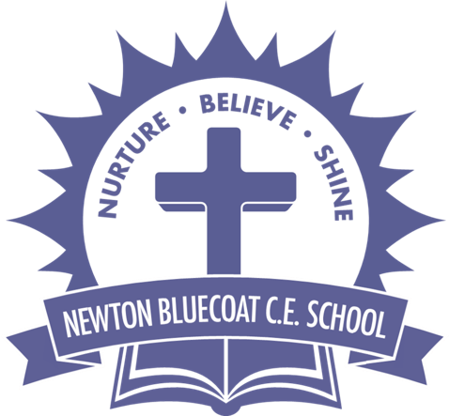 |  | Year: |  | Year 3/4 | Unit: |  | How can we re-discover the  wonders of Ancient Egypt?
What will I learn this year?
Children will learn about the achievements of the earliest civilizations – using an in-depth study of Ancient Egypt.

They will:
- Continue to develop a chronologically secure knowledge and understanding of British, local and world history,
- Learn about the achievements of Ancient Egypt.
- Make links between and across periods, such as the difference between clothes, food, buildings and transport.
- Understand some methods of historical enquiry, and how evidence is used to make detailed observations, finding answers to questions about the past.

Learning will include finding out about Howard Carter and his discovery of Tutankhamun’s tomb; the importance of the
pyramids; their belief system centred around the Pharaohs and how the Egyptians were the first civilisation to invent writing.
Key Vocabulary |  |  |  |  |  | What should I already know?
Hieroglyphics | A system of writing using symbols instead of letters. |  | BELIEFS  The Ancient Egyptians really valued life after death. Pharaohs (who were the rulers of Ancient Egypt and were very powerful) would be buried in pyramids (their tomb) with their belongings including clothes, furniture, food and games so that they had everything they needed in the afterlife.  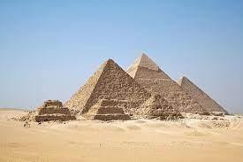  The Ancient Egyptians also believed in many different Gods who all had an important role e.g. Anubis – the God of death/Mummification.  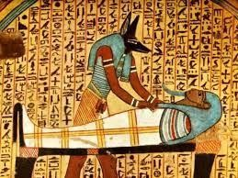  Ancient Egypt and the River Nile. |  |  | - I should already know the terms BC, AD, BCE, CE
Mummification | A method of preparing a dead body so it  doesn’t decay. |  |  |  |  | - I should have used evidence from primary and secondary sources to make historical claims.
Civilisation | A level of development at which people live together in a community. |  |  |  |  | - I should have plotted periods of history on a timeline.
Archaeology | The study of human history and prehistory through the excavation of sites analysis of remains. |  |  |  |  | - I should have recognised how lives in the past are different from ours.  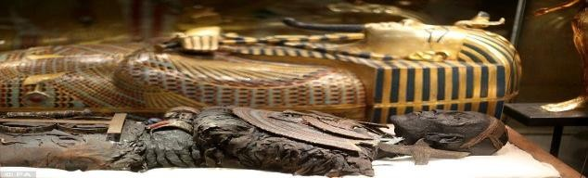
Papyrus | A plant that grew on the banks of the river Nile which was used for paper.

Canopic Jar | Special jars that held the organs of the dead. | 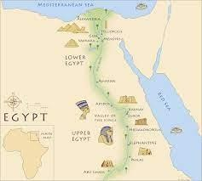 | What will I learn next?
Sarcophagus | A large stone box that held the  mummy’s coffin. |  | - I will learn about the lives of wealthy and poor Ancient Egyptians using various primary and secondary sources.
Tomb | A large vault typically built underground to bury the dead. |  | - I will learn about their gods and belief systems.
Irrigation | A system of canals and channels dug by Egyptians to supply water to grow crops over a wider area than water from the  Nile would normally reach. |  | - I will learn about the importance of the River Nile.
Silt | Fine particles of clay, soil and sand  carried and left by water. |  | - I will learn about some important dynasties.

