 |  | Year: |  | Year 5/6 | Unit: |  | How did Hitler convince a nation to follow him?
What will I learn this year?
- In depth study of different periods, using appropriate vocabulary when describing the passing of time and historical concepts (propaganda, bias, primary source, secondary source, reliability…)
- Understand significant aspects of history.
- Produce structured work that makes connections, draws contrast, analyses trends, frames historically-valid questions. Involving thoughtful selection and organisation of relevant historical information using appropriate dates and terms.
- Begin to recognise why some events, people and changes might be judged as more historically significant than others.
National Curriculum – History
- A study of an aspect of history or a site dating from a period beyond 1066 that is significant in the locality.
- A significant turning point in British history, for example, the first railways or the Battle of Britain.
National Curriculum links to other subjects
PSHE and Citizenship
- Recognise and identify different stereotypes and forms of discrimination against people in societies
- Consider the impact that discrimination has on people’s lives – empathy
Key Vocabulary |  |  |  |  |  | What should I already know?
Anti-Semitism | Hatred and persecution of Jews. |  | Adolf Hitler (1889-1945) Dictator of Germany 1933 - 1945  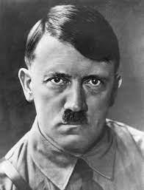  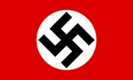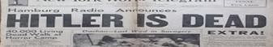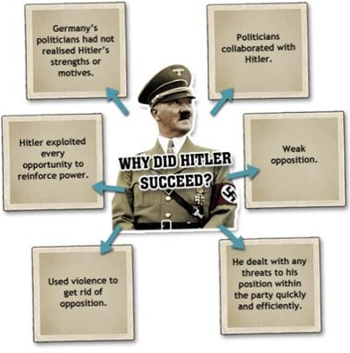  towneleyhall@burnley.gov.uk |  |  | - I should know Britain fought against Germany in the Second World War.
Great Depression | A large economic slump in the 1930s which led to high levels of unemployment. |  |  |  |  | - I should know the Second World War is still in living memory. Know that Nazi Germany was defeated. Know that Adolf Hitler was the leader of Nazi Germany
Propaganda | Misleading information spread with the intention of promoting a cause or belief. |  |  |  |  | - Have experience sequencing events and periods using appropriate time vocabulary.
dictator | A ruler with total power over a country. |  |  |  |  | - How to use sources to form opinions about the past
Swastika | Emblem of the Nazi party
Third Reich | Nazi name for Germany under Hitler’s rule. Means ‘Third Empire’. |  |  |  |  | What will I learn next?
General Election | People vote for those they want to represent them. |  |  |  |  | - I will learn how Hitler secured his position in Germany as leader.
appeasement | Making political or material concessions to an aggressive power in order to avoid conflict. |  |  |  |  | - I will learn how appeasement by France and Britain allowed Hitler to break the Treaty of Versailles.
Reichstag | The German Parliament |  |  |  |  | - I will learn about the persecution of the Jews and the use of propaganda to manipulate the German population.
Manifesto | A public declaration of a party’s political promises

Sticky Knowledge | Recommended Reads
World War 2 was a battle between two groups of countries – the “Allies” and the “Axis“. The major Allied Powers were Britain, France, Russia, China and the United States. The major Axis Powers were Germany, Italy and Japan.  Adolf Hitler, together with the Nazi Party, wanted Germany to rule Europe. To gain more land and power, on 1 September 1939 German troops invaded Poland. After Hitler refused to stop the invasion, Britain and France declared war on Germany – World War II had begun.  During the course of the war, German forces advanced through Europe. By the summer of 1941 they had invaded France, Belgium, Holland, Luxembourg, Denmark, Norway, Greece, Yugoslavia and the USSR.  Millions of Germans were imprisoned and killed because they didn’t fit the image of the ‘perfect’ German. Hitler wanted to create what he thought was the “best” and strongest race – and to the Nazi Party, this excluded certain groups, such as Jews, Gypsies and those with physical and mental disabilities.  The group most heavily targeted by the Nazis were the Jews. Around six million Jewish people were killed during World War 2 in one of history’s most terrible events – the Holocaust. Racist in his views, Hitler blamed Jewish people for Germany losing World War I and claimed they were dangerous to German people and society.  The US didn’t join the war until 1941, when Japan attacked the United States - at their Naval Base at Pearl Harbour in Hawaii. On 8 December 1941 (the very next day), the US declared War on Japan and, in turn, its German allies  Some countries remained ‘neutral’ in World War 2. Such countries were Spain, Sweden and  Switzerland – who chose not to join either side  The Germans surrendered on 8 May 1945. In 1944, an Allied army crossed from Britain to free France from Nazi rule. One year later, Allied armies invaded Germany, forcing the Germans to surrender.  After nuclear attacks on Japan’s major cities Hiroshima and Nagasaki, Japan also surrendered to  Allied forces in August the same year. World War 2 had ended | 

