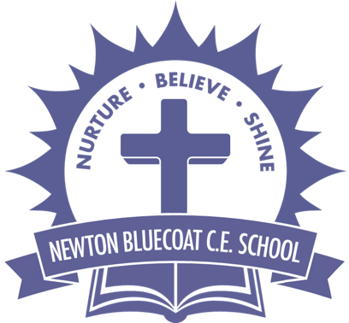 | Year: | Year 5/6 | Unit: | Were the Anglo – Saxons really smashing  and successful?
What will I learn this year?
- In depth study of different periods, using appropriate vocabulary when describing the passing of time and historical concepts.
- Gaining historical perspective by placing their growing knowledge into different contexts between cultural, economic, military, political religious and social history.
- Produce detailed structured work to select and deploy information and make appropriate use of historical terminology and contrasting evidence.
- Begin to recognise why some events, people and changes might be judged as more historically significant than others.
National Curriculum - History
- Anglo-Saxon invasions, settlements and kingdoms: place names and village life
- Anglo-Saxon art and culture
- Christian conversion – Canterbury, Iona and Lindisfarne
National Curriculum links to other subjects
- Art – Have an increasing awareness of different kinds of art, craft and design.
- Geography - Locate the world’s countries, using maps to focus on Europe (including the location of Russia)

museums.education@lancashire.gov.uk outreach services available

Key Vocabulary |  | Before 886AD After 886 AD  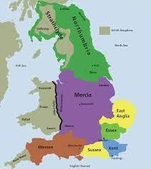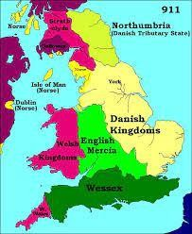  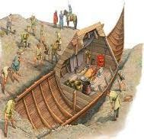  Sutton Hoo: An Anglo-Saxon ship burial  Discovered by Archaeologists in 1939.  Primary sources found at Sutton Hoo.  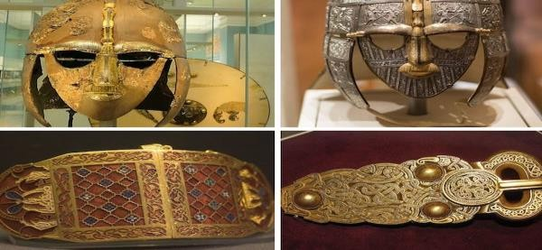 | What should I already know?
Primary sources of evidence | Evidence created during the time being studied by the people of that time. |  | - I should already know the terms BC, AD, BCE, CE
Secondary sources of evidence | Evidence created by other people based on primary evidence. |  | - Understand some methods of historical enquiry.
Artefact | A historical object. |  | - I should have used a variety of sources to form constructive responses.
Tribe | Group of people of the same culture. |  | Sticky Learning  Sticky Knowledge about the Anglo-Saxons
Monk | A man who has devoted his life to his religion and lives in a religious community. |  | - The Anglo-Saxons were made up of three tribes: the Angles; Saxons; and, Jutes.
Raiders | People who attack, then take what they find away with them. |  | - They name ‘Angles’ eventually became ‘English’ and their land became ‘England’.
Paganism | The religion of the Anglo-Saxons who believed in many gods. |  | - They came to Britain from across the North Sea in the middle of the 5th century.
Conversion | Change. |  | - For a long time, England was not one country, Anglo-Saxon kings ruled lots of small kingdoms across the land.
Monastery | Building where monks live. |  | - The Anglo-Saxons were fierce people who fought many battles, including fighting each other
Society | The people who live in a place and their way of life. |  | - The Anglo-Saxon period ended when the Normans conquered Britain in 1066.

** For teachers planning
History - End of Year Expectations

Year 6 | ⯈ Use dates and a wide range of historical  terms when sequencing events and periods of time.  ⯈ Develop chronologically secure knowledge  of the events and periods of time studied.  ⯈ Analyse links and contrasts within and  across different periods of time including short-term and long-term time scales.  Week 1  Week 2  Week 3  Week 4  Week 5  Week 6 | ⯈ Describe aspects of the Viking and Anglo-  Saxon struggle for the Kingdom of England in the time of Edward the Confessor.  ⯈ Demonstrate knowledge of an aspect or  theme in British history that extends their chronological knowledge beyond 1066. | ⯈ Regularly address and sometimes devise  historically valid questions and hypotheses.  ⯈ Give some reasons for contrasting arguments and interpretations of the past.  ⯈ Describe the impact of historical events and  changes.  ⯈ Recognise that some events, people and changes are judged as more significant than others. | ⯈ Acknowledge contrasting evidence and  opinions when discussing and debating historical issues.  ⯈ Use appropriate vocabulary when  discussing, describing and explaining historical events.  ⯈ Construct informed responses to historical  questions and hypotheses that involve thoughtful selection and organisation of relevant historical information including appropriate dates and terms.  ⯈ Choose the most appropriate way of  communicating different historical findings.
Year 5 | ⯈ Use dates and appropriate historical terms  to sequence events and periods of time.  ⯈ Identify where people, places and periods of time fit into a chronological framework.  ⯈ Describe links and contrasts within and  across different periods of time including short-term and long-term time scales. | ⯈ Describe some aspects of Britain’s  settlement by Anglo-Saxons and Scots.  ⯈ Demonstrate knowledge of Ancient Greece including Greek life and achievements and their influence on the western world.  ⯈ Describe key aspects of a non-European  society such as the early Islamic civilisation. | ⯈ Use a wider range of sources as a basis for  research to answer questions and to test hypotheses.  ⯈ Recognise how our knowledge of the past is  constructed from a range of sources.  ⯈ Evaluate sources and make simple inferences.  ⯈ Choose relevant sources of evidence to  support particular lines of enquiry. | ⯈ Discuss and debate historical issues.  ⯈ Use appropriate vocabulary when discussing and describing historical events.  ⯈ Construct responses to historical questions  and hypotheses that involve selection and organisation of relevant historical information including dates and terms.  ⯈ Choose relevant ways to communicate  historical findings.

Word Aware Vocabulary to be taught directly |  |  | Recommended Reads  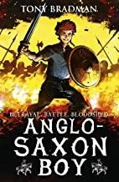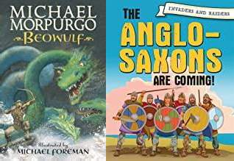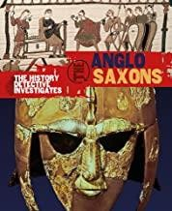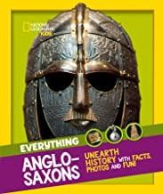
May cross over depending on year group and previous experiences
Tier 1 | Tier 2 | Tier 3
sequence chronological tribes  crime punishment defend kingdom settle / settled artefacts culture | invaders coast law justice modern jury  hypothesis relevant construct interpretation evidence conclusion examine | Tithing  Hue and cry Wergild

