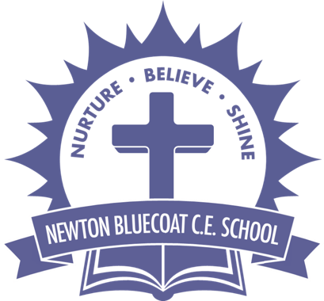 |  | Year: |  | Year 3/4 | Unit: |  | Who were the Ancient Greeks?
What will I learn this year?
- Using specialist dates and terms, place topics studied into different periods.
- Describe how Britain has been influenced by the wider world.
- Construct thoughtful responses that involve thoughtful selection and organisation of relevant historical information.
- Understand some of the methods of historical enquiry, how evidence is used to make historical claims. National Curriculum - History
- Ancient Greece – a study of Greek life and achievements and their influence on the western world.
National Curriculum links to other subjects
- PSHE and Citizenship
- Art
- Geography
museums.education@lancashire.gov.uk Outreach services available
Key Vocabulary |  |  |  |  |  | What should I already know?
Acropolis | An ancient citadel (fortress) usually  on a hill. |  | Ancient Greece  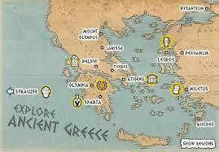  The acropolis in Athens  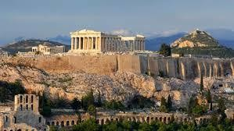 |  |  | - I should already know the terms BC, AD, BCE, CE
Assembly | A group of citizens who turned up to vote. |  |  |  |  | - I should have used evidence from primary and secondary sources to make historical claims.
Civilisation | A level of development at which people live together in a community. |  |  |  |  | - I should have plotted periods of history on a timeline.
Democracy | A form of government where citizens have a say in how they are ruled. |  |  |  |  | 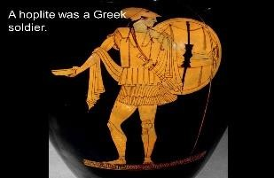  - I should have recognised how lives in the past are different from ours.  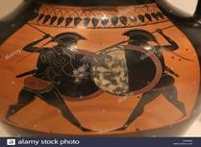  Greek hoplite soldiers
Citizens | An inhabitant of a town or city.

Dictatorship | Ruled by one person (a dictator) who has total power over a country. | The first Olympic games was in 776BC  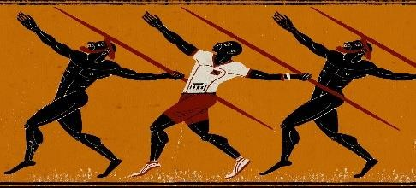 | Sticky Learning  Sticky Knowledge about Ancient Greece
Olympics | An athletic event held every 4 years. |  | - Ancient Greece was a civilisation made up of city states. It existed from around 700BC.  - Sparta and Athens were two city states in Ancient Greece. Most city states were similar to Athens. Life in Sparta was very different to life in Athens. In Sparta, men had to be in the army. Women and girls in Sparta had more freedom than in Athens as they could go to school and leave the house without a man’s permission.  - The Ancient Greeks worshiped lots of different gods (similar to the Ancient Egyptians). Zeus was the king of the gods. The gods had different powers. Some other gods are Athena, Aphrodite, Poseidon and Hades.  - Some things that we have and do today were influenced or invented by the Ancient Greeks. The Olympic Games, the marathon, theatre, Maths, Science and medicine were all influenced by the Ancient Greeks.
Myth | A traditional story explaining the history of people or a natural phenomenon.
Architecture | The art or practise of designing and constructing buildings.
Philosophy | The study of the fundamental nature of knowledge, reality and existence.

Word Aware Vocabulary to be taught directly |  |  | Recommended Books  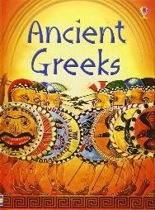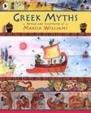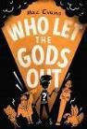
May cross over depending on year group and
previous experiences
Tier 1 | Tier 2 | Tier 3
To be added by teachers when planning individual lessons

