Y1 - Hot and Cold Places Key Learning
We will be able to name and locate the world’s seven continents and five oceans. We will identify seasonal and daily weather patterns in the UK. Using maps, we will identify the location of hot and cold areas of the world in relation to the Equator and the North and South Poles. We will know that maps give information about places in the world and be able to locate land and sea on maps.
Key Questions | Key Vocabulary
What do we mean by hot/cold places in the world? | Land – the solid part of the earth’s surface which is surrounded by water
Where are the hot/cold places in the world? | Season – the year is divided into Spring, Summer, Autumn and Winter which is related to the weather
What is the weather like in the hot places? (near the equator) | Ocean – a large expanse of sea
What is the weather like in the cold places? (near the North and South pole) | Continent – seven main divisions of land (Europe, Asia, Africa, North America, South America, Australia, Antarctica
What sort of animals live in these hot/cold places? | Antarctic – the continent surrounding the South Pole
What sort of plants live in these hot/cold places? | Equator – an imaginary line through the centre of the earth which divides the world into North and South
Our learning will look like:
- Identifying human features in hot and cold places of the world e.g. types of housing, towns etc.
- Developing geographical vocabulary when naming and describing human and physical features. ▪
- Identifying a range of animals (and plants) that live in hot and cold places of the world.
- Comparing the sorts of animals found in hot/cold places with animals in the UK.
- Locating and labelling the position of the Equator and the North and South Poles and also the seven continents and five oceans.
- Naming some of the countries through which the Equator passes.
- Focusing on the Continent of Antarctica and learning about what it is like to live there and some of the animals that have made it their home.
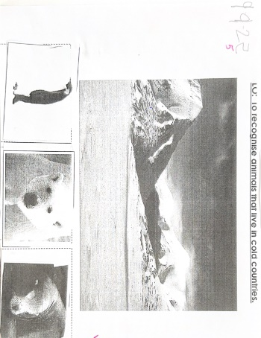
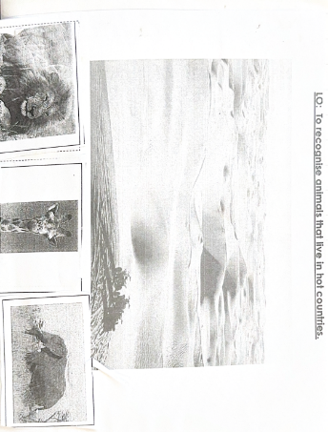
- Learning about features in hot and cold places of the world e.g. frozen environments, deserts, etc


