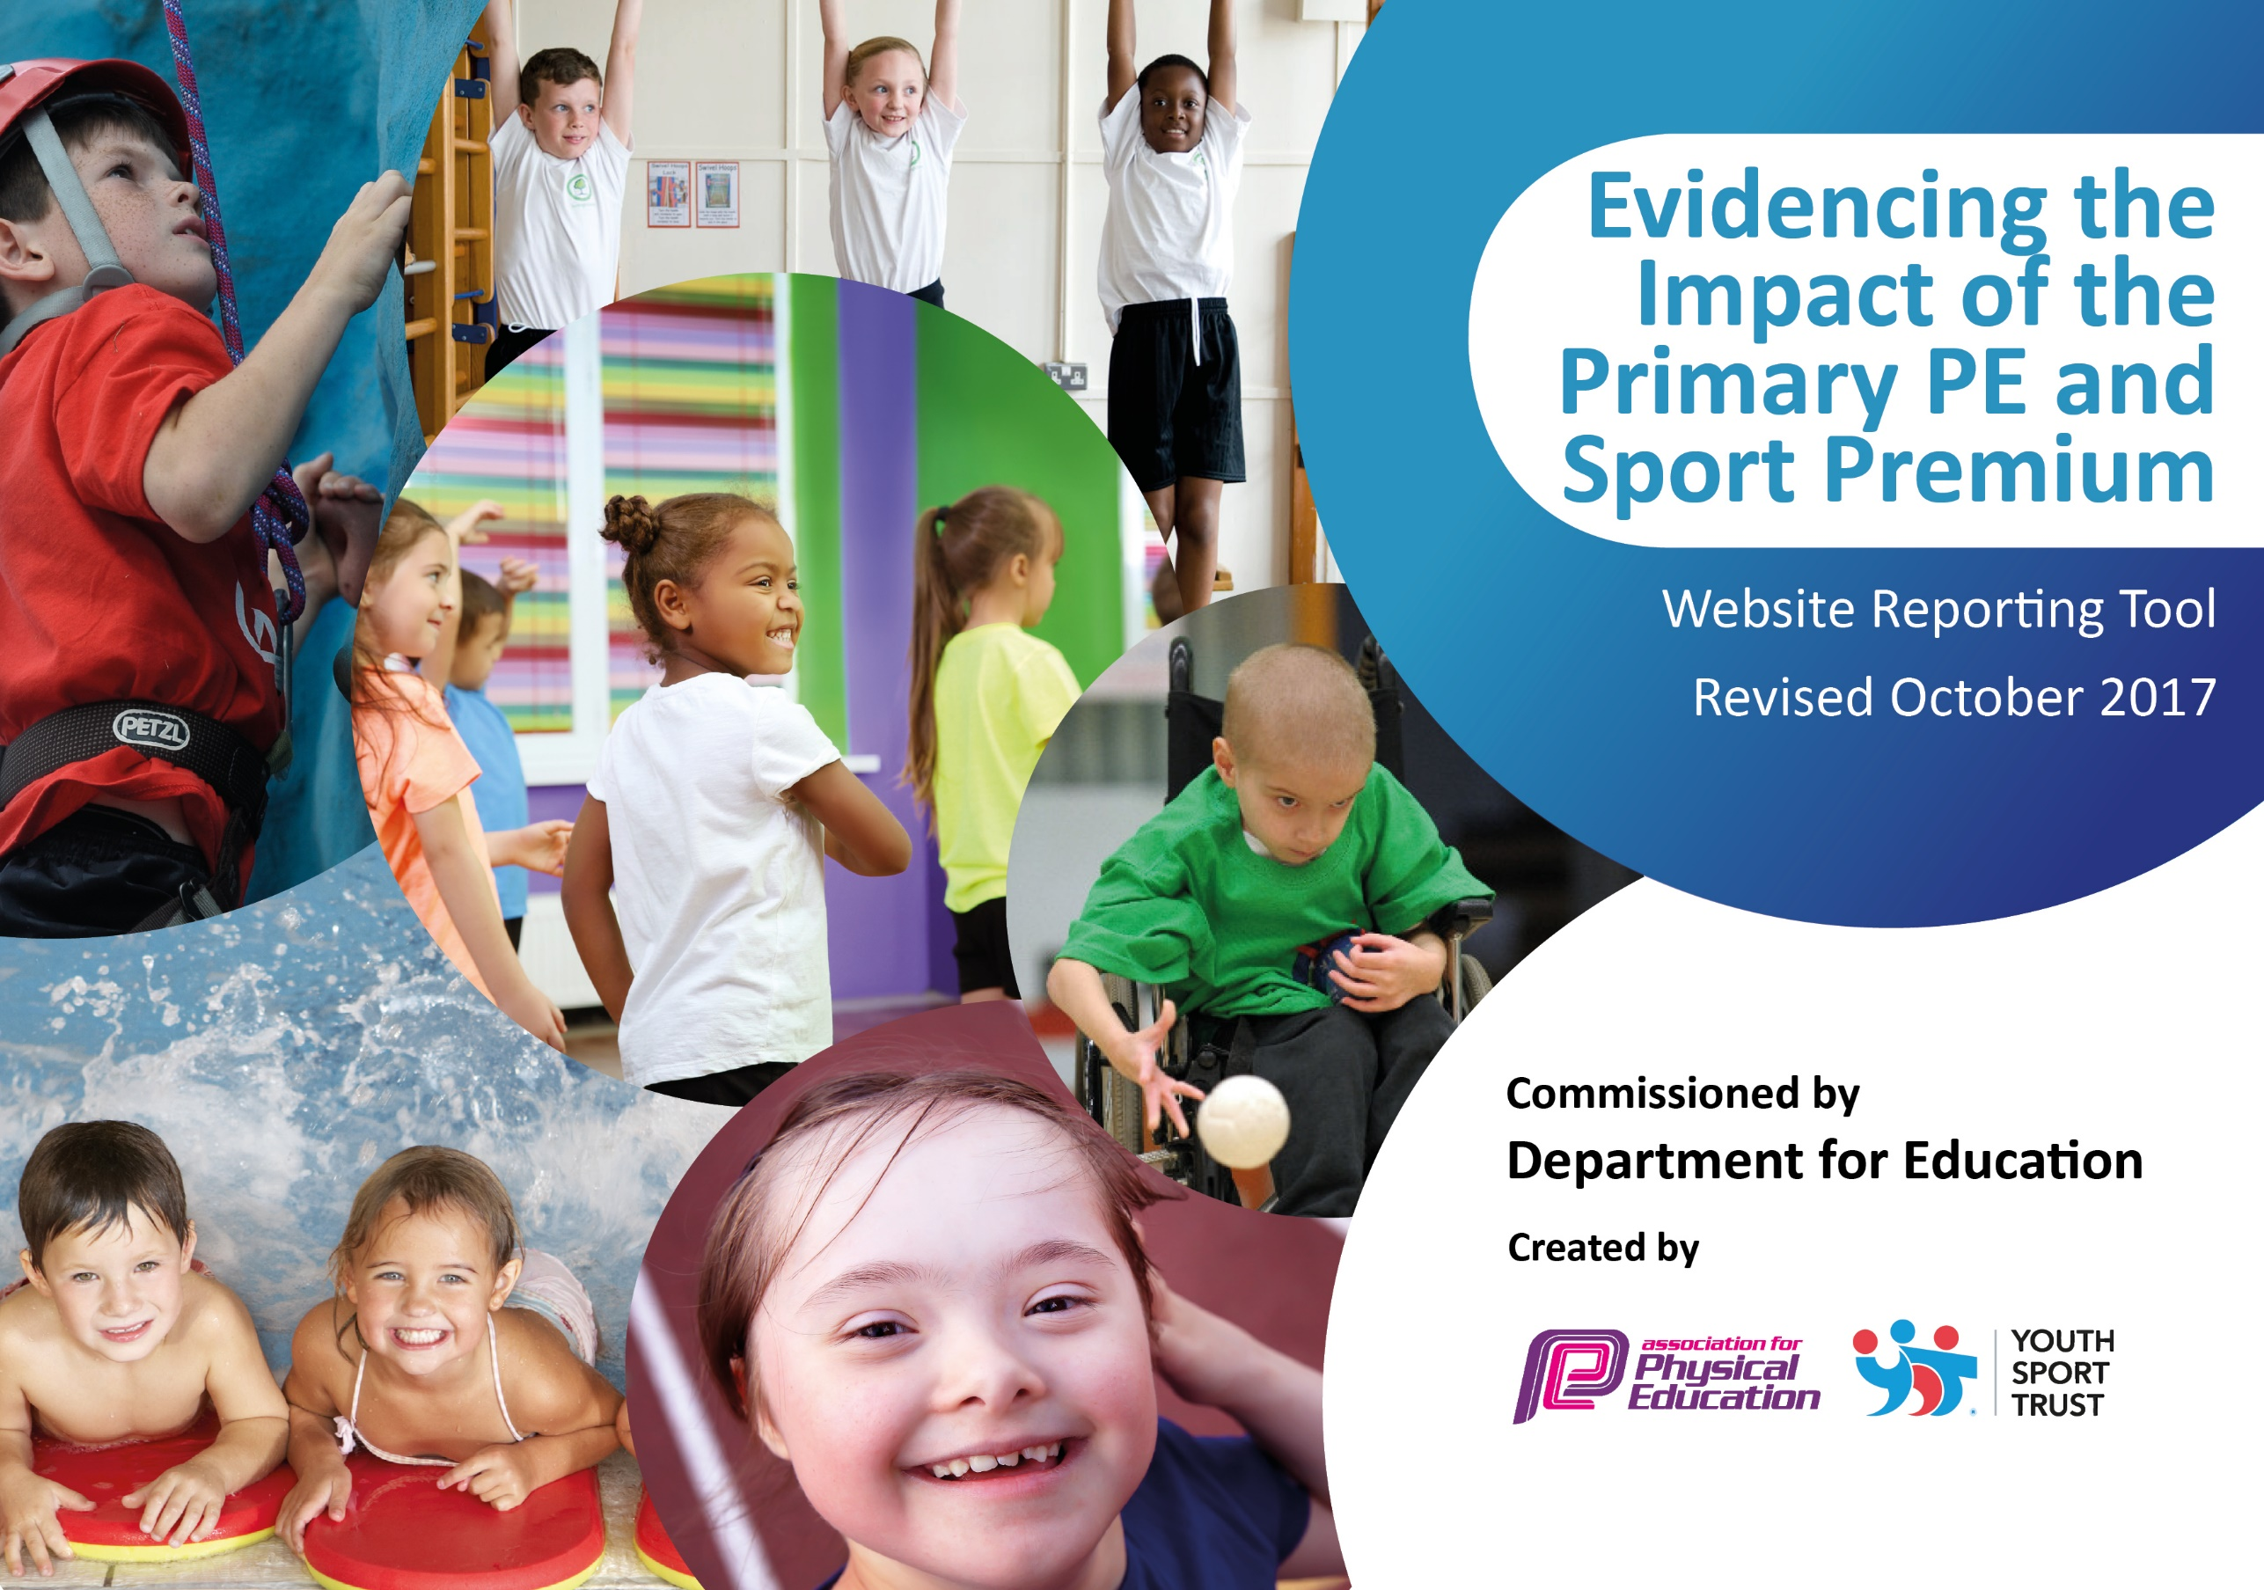

2023-2024

Schools must use the funding to make additional and sustainable improvements to the quality of PE and sport they offer. This means that you should use the Primary PE and Sport Premium to:

- develop or add to the PE and sport activities that your school already offers
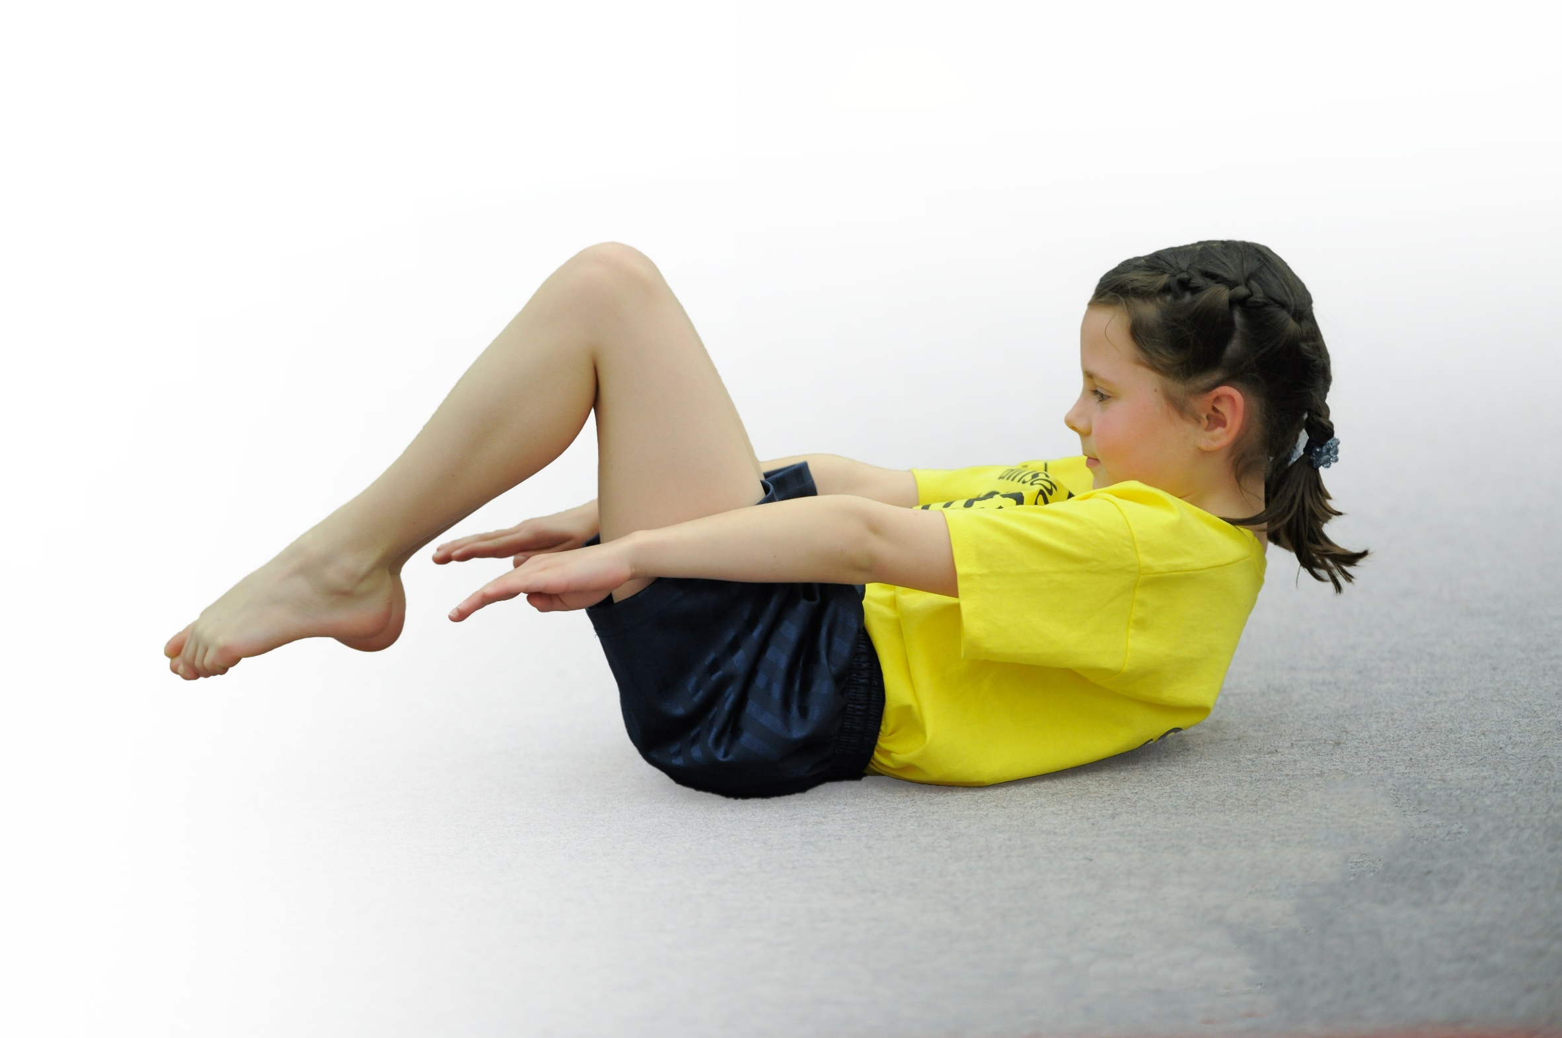
- build capacity and capability within the school to ensure that improvements made now will benefit pupils joining the school in future years

Please visit gov.uk for the revised DfE guidance including the 5 key indicators across which schools should demonstrate an improvement. This document will help you to review your provision and to report your spend. DfE encourages schools to use this template as an effective way of meeting the reporting requirements of the Primary PE and Sport Premium.

We recommend you start by reflecting on the impact of current provision and reviewing the previous spend.
Under the Ofsted Schools Inspection Framework, inspectors will assess how effectively leaders use
the Primary PE and Sport Premium and measure its impact on outcomes for pupils, and how effectively governors hold them to account
for this.

Schools are required to publish details of how they spend this funding as well as on the impact it has on pupils’ PE
and sport participation and attainment.
We recommend regularly updating the table and
publishing it on your website as evidence
of your ongoing review into how you are using the money
to secure maximum, sustainable impact. To see an example of how to complete the table please click HERE.

Support for review and reflection - considering the 5 key indicators from DfE, what development needs are a priority for your setting and your students now and why? Use the space below to reflect on previous spend, identify current need and priorities for the future.

Key achievements to date: | Areas for further improvement and baseline evidence of need:
- Employed new and maintained local coaches to provide extracurricular sporting opportunities – Fylde Rugby Club, Dance Club with Miss Kate, Julian Wilson-tennis & multi-skills, Cricket Development coach.  - Provided a range of competitive opportunities for all children.  - Worked closely with the local SSP, accessing all that is on offer.  - Developed a wide and varied curriculum/extra-curricular program and provided all children to be able to access as many opportunities and experiences as possible.  - Rugby Reading Champions to improve reading in Year 5 to the lower 50% | - To sustain a high quality curriculum using the knowledge and skills received from CPD. Identify any gaps within the school that need addressing.  - To continue to develop staff CPD and confidence to ensure high quality PE is taught throughout school.  - Continue to use and develop the use of PE Passport in regards to assessment for learning in PE lessons.  - Developed multiple opportunities for children to be physically active throughout the school day, in addition to the PE curriculum.

Meeting national curriculum requirements for swimming and water safety | Please complete all of the below:
What percentage of your Year 6 pupils could swim competently, confidently and proficiently over a distance of at least 25 metres when they left your primary school at the end of last academic year? | 25/29 = 86%
What percentage of your Year 6 pupils could use a range of strokes effectively [for example, front crawl, backstroke and breaststroke] when they left your primary school at the end of last academic year? | 25/29 = 86%
What percentage of your Year 6 pupils could perform safe self-rescue in different water-based situations when they left your primary school at the end of last academic year? | 25/29 = 86%
Schools can choose to use the Primary PE and Sport Premium to provide additional provision for swimming but this must be for activity over and above the national curriculum requirements. Have you used it in this way? | No

Action Plan and Budget Tracking
Capture your intended annual spend against the 5 key indicators. Clarify the success criteria and evidence of impact that you intend to measure to evaluate for students today and for the future.

Academic Year: 2023 – 2024 | Total fund allocated: £17022.64 | Date Updated: June 2024
Key indicator 1: The engagement of all pupils in regular physical activity – Chief Medical Officer guidelines recommend that primary school children undertake at least 30 minutes of physical activity a day in school |  |  |  | Percentage of total allocation:
 |  |  |  | %
School focus with clarity on intended impact on pupils: | Actions to achieve: | Funding allocated: | Evidence and impact: | Sustainability and suggested next steps:
At Newton Bluecoat, we firmly believe that EVERY CHILD should benefit from the Sport Premium funding and that EVERY CHILD should be engaged in the physical activity they are doing. As well as planning and delivering high quality lessons, we offer a wide range of other opportunities for our children to be physically active during the school day and during extra-curricular times also. Our aim is rather than 30 minutes of activity per day, we want our children to be active for 40 minutes per day to ensure they are healthy and build a positive relationship with exercise that can last them a lifetime. | - Progressive, well planned lessons delivered through the Lancashire P.E. Passport App membership.  - Wide range of high interest extracurricular activities. These are staged in different year groups across school throughout the year to maximise participation.  - Monday - Rugby Rug Rats –Rec/Y1/Y2 – 16 children  - Tuesday - Football Club: year 4/5/6 – 25 children  - Tuesday - Rounders Club: year 5/6 – 24 children  - Tuesday - Cricket Club: year 4/5/6 – 26 children  - Wednesday – Netball – Y4/5/6- 20 children  - Wednesday – Athletics Club: years 3,4,5 & 6 - 70 children  - Tuesday – Dance – Y4/5/6 – 28 children  - Thursday – Multi skills: Years 1-2 – 16 children.  - Friday tennis - KS2 – 18 children.  - Forest School sessions for Nursey and Reception.  - Fylde Rugby Club provide playtime Sports with EYFS & KS1 – 30mins. KS2 – 30mins on Fridays.  - School Track used by every child in school.  - Wider opportunities for the children to engage in physical activity. Years 5 & 6 spent 3 days at Tower Wood.  - Year 5 children spent a day at Bewilderwood Cheshire to engage in high rope activities. | P.E. Passport membership - £679  Dance - £560.74  Dance - £75.00  Fylde Rugby - £4,360.00  Tennis - £189.00  Cricket - £299  Total - £5558.74  on club providers to support staff leading clubs, which acted like CPD for our future benefit | The profile of exercise and P.E. has continued to rise and children in our school have a positive impression of P.E. and physical exercise. Children understand that they need to exercise and exercise can be hard sometimes, but that it is vital for our bodies and our long term health. This is all supported by Pupil Voice questionnaire data.  Children have thoroughly enjoyed the competitive nature of being physically active as a class – participation and engagement has definitely been raised as classes have engaged physically.  Forest Schools allowed children to be active whilst discovering awe and wonder – SMSC. | Extra-curricular clubs run this year were ran by staff and by alternative providers. This is highly sustainable and will run again next year.  We are signed up to the P.E.  Passport App. For a further 3 years which will provide long-term stability for our P.E. curriculum and ensure our children have an excellent amount of in-curriculum time physical opportunities.  Our SSP competitions are one of the biggest successes in our sporting achievements. The engagement levels from all children across school are very high. They are very sustainable and we aim to build on this.
Key indicator 2: The profile of PE and sport being raised across the school as a tool for whole school improvement |  |  |  | Percentage of total allocation:
 |  |  |  | %
School focus with clarity on intended impact on pupils: | Actions to achieve: | Funding allocated: | Evidence and impact: | Sustainability and suggested next steps:
We aim for P.E. and Sport to take a  prominent place in the curriculum  and strive for the children to take the  skills, experiences and enjoyment  they have in P.E. and apply them to  other areas of learning. The  character values taught through P.E.  encompass everything we want a  child to be at Newton Bluecoat – resilient, thankful, a team player, good communicator, fair, self-confident, respectful, hardworking and adaptable. Through developing these skills in P.E. lessons and school sport opportunities, the children can grow as individuals and apply these qualities to other areas of learning. Through creative and effective spending of the Sport Premium funding, we will provide additional opportunities for our children to further learn across the curriculum and apply their sporting and character skills in meaningful  ways. | - High quality teaching and learning opportunities provided by the Lancashire P.E. Passport App. This is used by all teaching staff across school and incorporate all the Christian and character values into teaching and learning opportunities.  - The track is used to engage children in exercise and ‘break up’ long periods of learning. Standing up, raising heart rate and moving physically have all been proven to increase the capacity for learning so these are used as short brain breaks or active break times to stimulate the children.  - Children in Year 6 were provided with the opportunity to spend 3 days at Tower Wood, where they worked on improving resilience, teamwork, determination, and resilience.  - House Captains to help with Athletics sessions in other classes once SATs finished in May. House Captains were responsible for choosing relay teams, music and making banners for their houses on Sports Day. They also helped set up equipment in practices and on the day.  - In and out of school achievements encouraged and celebrated in Friday’s Worship Assembly.  • Signed agreement for Gold Package at Carr Hill. LK to continue to take children to Level 2 and 3 competitions held at Carr Hill or other local sporting halls/arenas.  - TS to continue to complete admin for clubs and events, transport children to and from events and update paperwork and registers. | £400  £700 – transport to events  £8004.40 | Children have been actively engaged in all PE sessions. Staff comment on their growth as a character as well as in skills.  All staff have seen the positive impact that active break times and the use of the track have had on our children. The children are re-charged and can concentrate on tasks better once they have been active.  The opportunity of attending a residential saw the children grow in independence and adapt an, ‘I can’ approach to new learning and activities across the curriculum. Children understand that experiencing victory is not about always winning it is achieving a personal best.  This raised attainment of individual performances on Sports DAY and demonstrated values of responsibility, teamwork and communication between the children.  Children’s achievements are valued highly, promoting sense of well being and humanity as a community.  With different groups of children across the school attending the events, has had a huge success on improving the children’s mental wellbeing improving both their confidence and resilience. This has transferred through to other subjects such as Maths problem solving, science predictions and the culture of making a mistake is fine. | To continue to actively use sports captains throughout school to promote activity outside of the PE session.  Teachers to involve children in the next steps of their learning whilst promoting the school values.  Year 6 children will attend Tower Wood in October 2024.  Continue to celebrate all sporting achievements and encourage new sports.

Key indicator 3: Increased confidence, knowledge and skills of all staff in teaching PE and sport |  |  |  | Percentage of total allocation:
 |  |  |  | %
School focus with clarity on intended  impact on pupils: | Actions to achieve: | Funding  allocated: | Evidence and impact: | Sustainability and suggested  next steps:
We want our staff to be confident,  knowledgeable and enthusiastic about curriculum P.E. and the wider sporting opportunities we offer our children. We  firmly believe our staff are our strongest, most important resource and if we are going  to plan to leave a legacy for the Sports Premium expenditure, it needs to start by upskilling and training our staff to be outstanding practitioners. Staff should receive training and have a high level of confidence and familiarity with the scheme  of work in place and use this effectively to plan and assess P.E. Where staff are lacking in confidence or subject knowledge, training or support should be provided. | - To continue to fully embed the Lancashire PE scheme of work and PE Passport App.  - Subject leader to attend the Termly PE Updates.  - Staff questionnaires to be completed and professional conversations taking place with the subject leader to ensure staff members receive training or support where needed. |  | Outdoor Education Northwest delivered a twilight session to staff  demonstrating the skills needed to deliver a series of lessons to all ages of children. They also delivered a short session to all children so that staff could see this in practice.  More confident and competent staff, that have the ability and confidence to adapt the Lancashire PE plans to suit the needs of their class whilst still developing skills from EYFS to Year 6. There has been a very positive reaction to the P.E. Passport.  Through observing P.E. lessons, it is clear that children and staff are  aware of the correct techniques  required to master a certain skill  being taught and all children are  challenged effectively.  Improved links across subjects.  Pupil concentration, commitment, self-esteem and behaviour enhanced. Good citizenship promoted. Staff and children promote and demonstrate SMSC in PE sessions, clubs and active break times.  The high interest in clubs including those for KS1, have been successful. This will mean for years to come, children across the school can benefit from this training and support. | To book a session with OEN to deliver an orienteering day to the children in Autumn Term.  To continue to provide a variety of different clubs across all Key Stages to promote the success of taught skills in PE through school sport.  To source someone to deliver martial arts subject to cost.
Key indicator 4: Broader experience of a range of sports and activities offered to all pupils |  |  |  | Percentage of total allocation:
 |  |  |  | %
School focus with clarity on intended  impact on pupils: | Actions to achieve: | Funding  allocated: | Evidence and impact: | Sustainability and suggested  next steps:
In order to raise engagement within P.E. and sport and to increase the profile of physical activity, you have to make it meaningful and fun. We ensure our P.E. curriculum is balanced and varied so that every skill and character value needed is taught, but through different sports and activities across school. Through introducing the children to a wider range of games and sports, both team games and individual games, we are widening the net and giving them more opportunities to find a sport they really enjoy and excel at. We offer a range of sports and extra-curricular activities through our clubs, trips, residentials and whole-school events. This helps us reach our balance of teaching the children skills and techniques, but also giving them the chance to play and have fun! | - Variety of sports used for extra-curricular clubs to raise engagement. Indoor athletics, Quad Kids Athletics, Tennis, Football, Netball, Modern Dance, Multi-skills, Cricket, Rounders and Rugby Rugrats.  - To attend half-termly competitions held by Carr Hill offering different sports to engage the children in competitive sport.  - New equipment purchased to provide a balanced and varied curriculum via PE Passport – Netballs, bibs, balance benches and mats  - Bike ability for Year 5 – May/June 2024. | £1491.63  £263.87 | After-school clubs were attended in vast amounts and showed excellent engagement from children across school (see above data).  Our children’s experiences of physical activity and sport is very varied and positive. Children’s engagement and enjoyment during physical activity have both increased, showing the implementation as a success.  24/27 achieved level 2.  3/27achieved level 1. | To continue to offer a variety of clubs and take up offers from new coaches.  Children in Year 5 to complete Bikeability next year.
Key indicator 5: Increased participation in competitive sport |  |  |  | Percentage of total allocation:
 |  |  |  | %
School focus with clarity on intended  impact on pupils: | Actions to achieve: | Funding  allocated: | Evidence and impact: | Sustainability and suggested  next steps:
Our goal is to ensure every child in our school are provided with meaningful opportunities throughout the year to participate in competitive games and competitive sport. Skills, character values and tactics are learnt through P.E. lessons, but applied through games, sports and competitions. There is a place for high level competition, however for the most part competitions should not be elitist or put children off, as it so easily can in high pressured environments. Instead, we aim to build competitions around engagement and creating a positive atmosphere, where children can showcase their skills and talents in a supportive, team environment. | - Remain in Kirkham & Fylde Primary Schools’ Sports Partnership – Gold Package.  - Most children in KS2 to participate in at least one Level 2 event throughout the school year. |  | Attended festivals and competitions every half term.  Large majority of KS2 children have attended Carr Hill High School in a local festival or competition. 8 KS1 children attended a Football Skills event and also 8 children attended a Multi skills Festival.  Netball – 2nd in the league.  Football – 1st in the league.  Year 5&6 Athletics – 1st in local area heat.  Year 5&6 Athletics – 9th in Lancashire.  Year 3&4 Athletics – 1st in local area heat.  Dance – 1st in Fylde, 7th in Lancashire.  Year 5 & 6 winners of Quad Kids  Year 3 & 4 winners of Quad Kids | To sign the Gold Package again next year with a view to attend the Football and Netball League during the Autumn Term to compete against neighbouring schools to provide meaningful competitive opportunities for our children.

