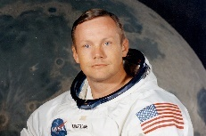
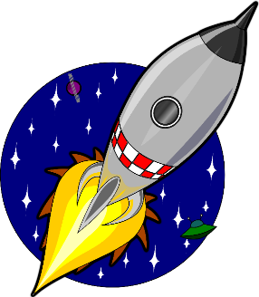
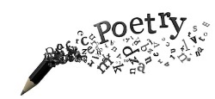

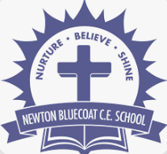

DT
We have been researching, designing and will be making moon buggys in DT! Can you bring some junk modelling cardboards boxes and bottle caps to perfect your model. Can you make a model rocket to go alongside your moon buggy? You could use toilet rolls and tin foil?

Welcome to the Year 2 home learning menu
We have created a menu of home learning opportunities for your child to complete throughout the half term. The minimum expectation is for your child to complete one task; however, they may also complete as many as they wish. In year 2 I have tried to make the activities hands on and engaging using our creativity and exploration skills.
Please bring the work into school at the end of the half term and we will showcase the work brought in by the class.
Thank You, Miss Watson
Newton Bluecoat Home Learning Menu
Topic: Explorers: Space
ART
Can you make a model Solar system with all the planets? It could be made from rocks, or balls or even paper mache! Get crafty and see what you can create!!
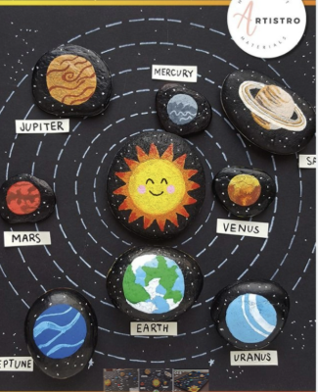

English
This term we will be performing our poem in assembly to the whole school! It is all about space and the things we will learn this term. Can you practice performing our space poem to your family and friends? Can you find the rhyming words?
Weekly Homework
Each week, your child is expected to read daily at home. Spellings will be sent home on a Friday with them being tested on the following Friday. We have started sending spelling books home for you to see your child’s score. Please return them for the following Friday test.
A weekly English and Maths task will be set on purple mash for you to access. These will be tasks we have been focusing on in the week to build our learning and understanding. Your child’s username and password will be in their reading diary however these are used regularly in school so your child should know them. A timetable challenge will be set alongside this. Year 2 expectations are to know the 2,5 and 10’s.

History
Carrying on with our space theme we have been learning about Neil Armstrong and Yuri Gagarin. Can you research any other famous space explorers in History? You could make a poster telling us all about them and what they achieved!
Maths
This week have started looking at shape. We have learnt a new song to help us remember the difference between 2D and 3D shapes. Can you go on a shape hunt around your house and bring in some 3D shapes to school. Maybe a cylinder can of beans? A triangular prism Toblerone? A sphere football?

Art

This term we are looking at Picasso and portraits.
Can you use the skills we have learnt so far to create a masterpiece portrait? You can use paint, pencils, crayons or even magazine cut outs!

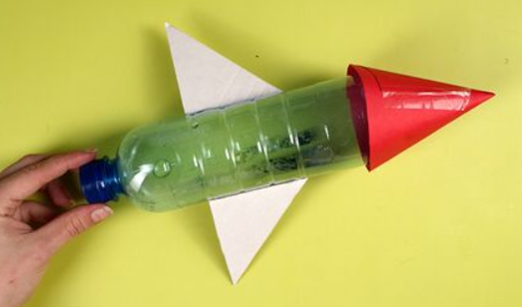
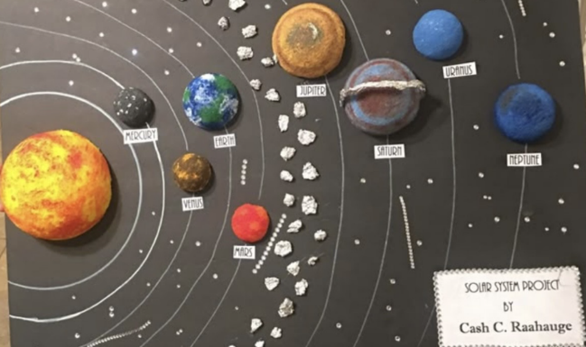

Our shape song!
2D shapes are flat, flat, flat,
3D shapes like a party hat,
2D shapes like circle and square,
3D Shapes that football there!!



