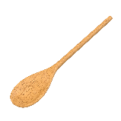
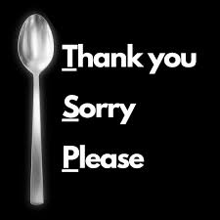
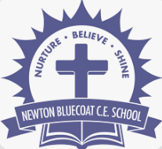
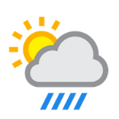
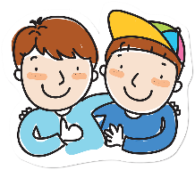
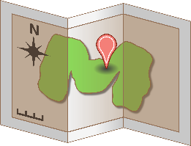

Welcome to the Year 2 home learning menu
We have created a menu of home learning opportunities for your child to complete throughout the half term. The minimum expectation is for your child to complete one task; however, they may also complete as many as they wish. In year 2 I have tried to make the activities hands on and engaging using our creativity and exploration skills.
Please bring the work into school at the end of the half term and we will showcase the work brought in by the class.
Thank You, Miss Watson
Newton Bluecoat Home Learning Menu
Topic: The Place where we live
RE
In assembly we have begun our Tea spoon prayers again. In Year 2 we have our own prayer tree where we can write a TSP and hang it on. Can you write a TSP at home? You could do it on paper, card, make it pretty or even make your own wooden spoon like we have in assembly!
PSHE
This term in PSHE alongside our ‘my Happy Minds’ we have been learning about what makes a good friend.? Can you write about your best friend, tell us what makes them such a wonderful friend and draw a picture of them!
Weekly Homework
Each week, your child is expected to read daily at home. Spellings will be sent home on a Friday with them being tested on the following Friday. We have started sending spelling books home for you to see your child’s score. Please return them for the following Friday test.
A weekly English and Maths task will be set on purple mash for you to access. These will be tasks we have been focusing on in the week to build our learning and understanding. Your child’s username and password will be in their reading diary however these are used regularly in school so your child should know them. A timetable challenge will be set alongside this. Year 2 expectations are to know the 2,5 and 10’s.

Science
Carrying on with our seasonal changes. Can you create a weather diary over the next few weeks and record the temperature and conditions. Have you had to change the clothes you’ve worn? Has it got hotter or colder? Is it lighter or darker earlier or later?
English
We have looked at our first poem all about fireworks this week. Make a list of 10 words that rhyme (e.g. cat, hat, mat…). Can you write a funny poem using them?


Art
This term we are looking at Picasso and portraits.
Can you use the skills we have learnt so far to create a masterpiece portrait? You can use paint, pencils, crayons or even magazine cut outs!
Geography
Continuing our topic on the local area and the place where I live. Can you draw a map of your local area and label key features, school, the park, the shop, your house!

