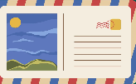


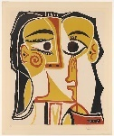
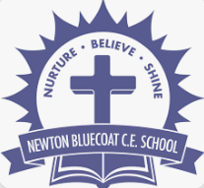

DT
This term in DT we will be making dips and dippers. Creating our own recipe with ingredients and instructions. Can you create your own recipe? You take some photos to go alongside your recipe so we can see your end result!
Weekly Homework
Each week, your child is expected to read daily at home. Spellings will be sent home on a Friday with them being tested on the following Friday. We have started sending spelling books home for you to see your child’s score. Please return them for the following Friday test.
A weekly English and Maths task will be set on purple mash for you to access. These will be tasks we have been focusing on in the week to build our learning and understanding. Your child’s username and password will be in their reading diary however these are used regularly in school so your child should know them. A timetable challenge will be set alongside this. Year 2 expectations are to know the 2,5 and 10’s.

Welcome to the Year 2 home learning menu.
We have created a menu of home learning opportunities for your child to complete throughout the half term. The minimum expectation is for your child to complete one task; however, they may also complete as many as they wish. In year 2 I have tried to make the activities hands on and engaging using our creativity and exploration skills.
At the end of the half term, we will showcase the work brought in by the class.
Thank You, Miss Watson
Science
Throughout the year we look at seasonal change and observe changes over time. We look at how habitats, minibeasts and plants change between the seasons.
Can you go on a minibeast hunt in your garden or local area and record your findings? There are some super tick lists on the Woodland Trust.
History
October is Black History month. In Year 2 we learn about Nelson Mandelaand the impact he made. Can you write a fact file on another person who changed our world and black history?
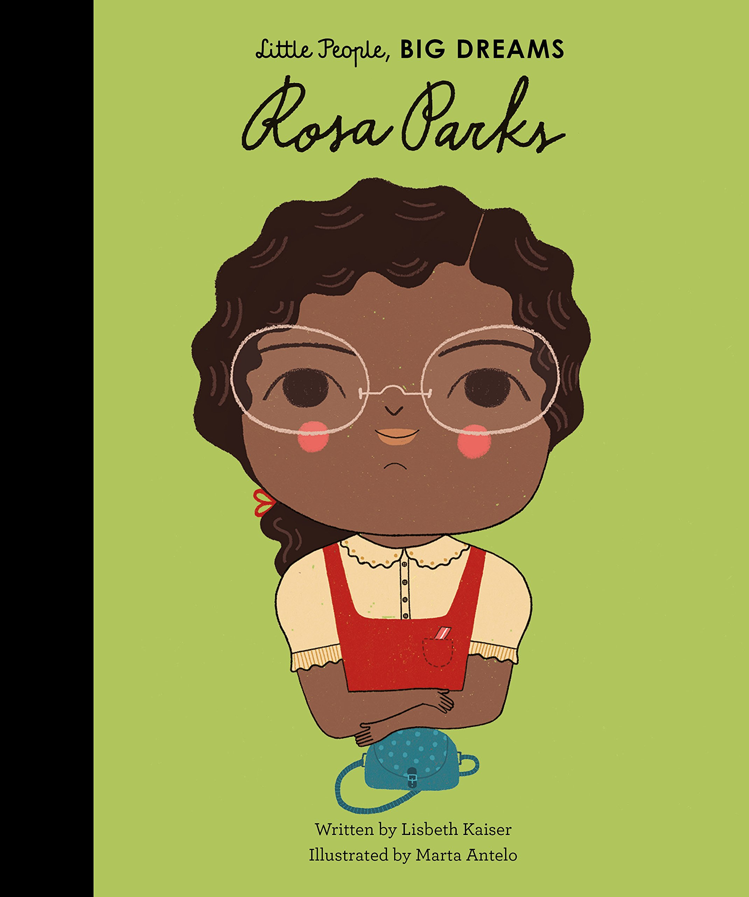

Art
This term we are looking at Picasso and portraits.
Can you use the skills we have learnt so far to create a masterpiece portrait? You can use paint, pencils, crayons or even magazine cut outs!
Geography
We have been looking at the place where we live starting with our planet diving right down to our postcode and home address.
Can you search for school on Google maps? Find our address and send a post card to school?
Newton Bluecoat Home Learning Menu
Year 2
Topic: The Place where we live

