
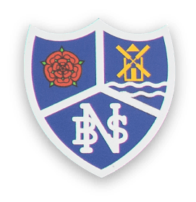
Year 2 Class Letter
Autumn Term 2025
Welcome to Year Two
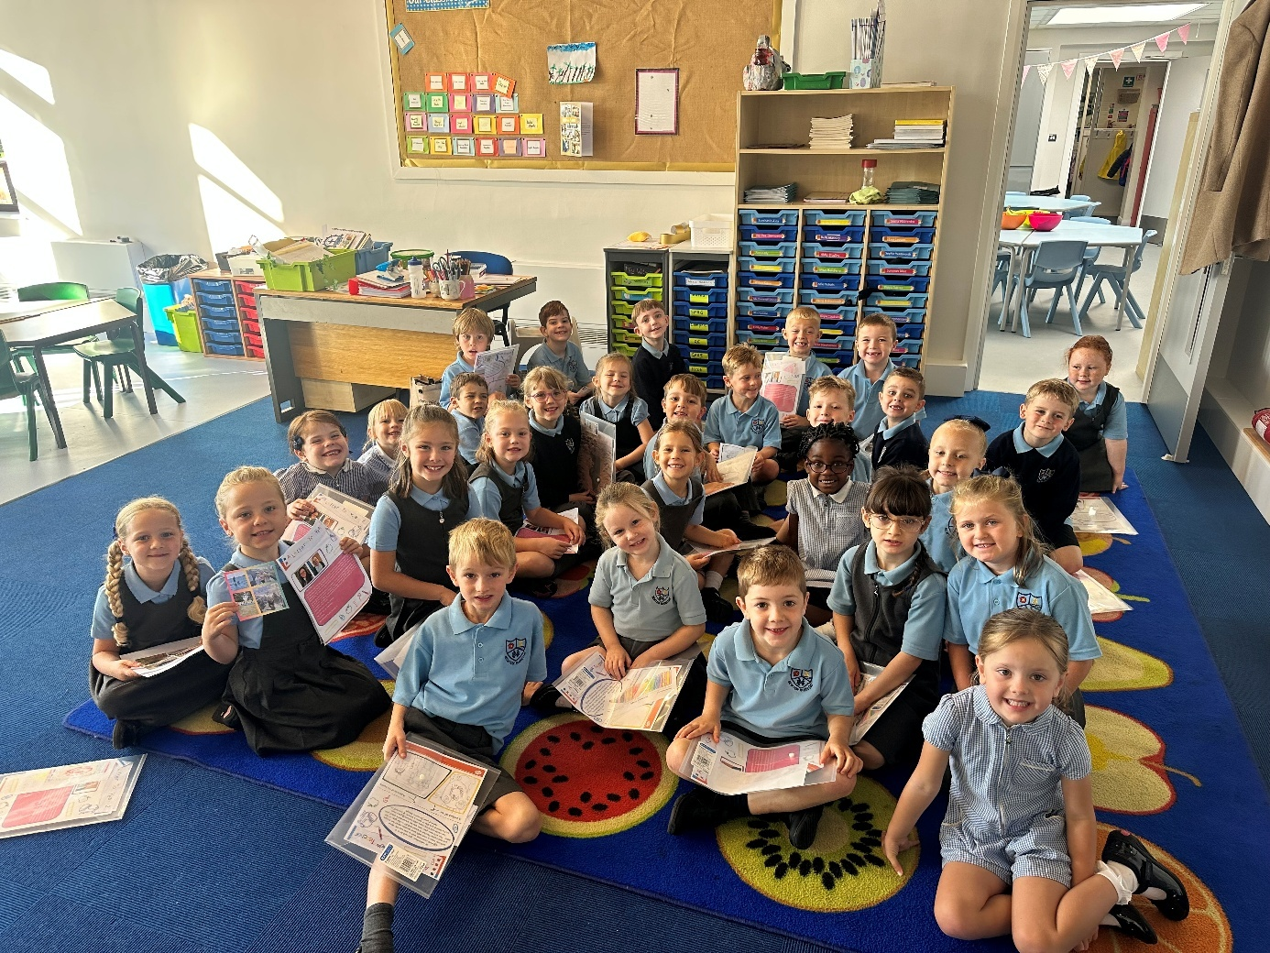
We have made a brilliant start to Year 2 embracing the challenge and Year 2 demands. Alongside getting stuck in with our Maths and English, we have enjoyed learning about the 7 continents and 5 oceans through songs and maps, we have investigated materials in Science and started learning about Picasso and inspired our inner Artist ready to draw self portraits!

On Friday we had a busy morning with our first Year 2 spelling, times tables and arithmetic tests, finishing off with a fun Friday afternoon golden time and reading to Miss Watson!

Well done Year 2 a fantastic start!

Our topic for this term is: The place where I live

English
This term we will look at narrative – stories with familiar settings and non-narrative – instructions, information texts. The children will be working on improving their writing by looking at punctuation and sentence structure. We will develop our joined handwriting skills and overall neatness of work.
The children will have a daily whole class SPAG lesson, Guided reading session and an English lesson. Weekly spellings will be sent home and these will be the words Year 2 are expected to be able to spell. Please spend time each week going over the words with your child.
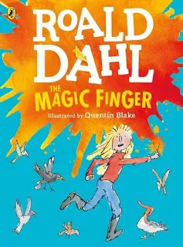
Reading books are sent home on a Monday, Tuesday, Wednesday and Thursday. Your child will bring home a book closely matched to their phonic ability. Please allow time to listen to your child read, many of our new reading books have prompts for parents to help you as you read together with your child.

Next week we will start our new class
novel that we read every day at
home time. This term is it:

The Magic Finger by Roald Dahl.

Maths
This term we will be focusing on Place Value, Addition and Subtraction and shape. The children should also be able to recall and use multiplication and division facts for the 2, 5 and 10 times tables.

Homework
We are currently reviewing our homework policy. Homework will not be sent out over the next few weeks and we will keep you updated on any changes and new plans!

SPELLINGS – given out on Friday.

READING – books come home Mon, Tues, Weds, Thurs, please return daily even if the book has not been completed

PE
Our PE sessions will vary each term so please ensure your child always has their named kit in school. This term we will be doing PE on a Monday/Tuesday. A pair of trainers is also helpful for when we are outside or if they wish to participate in organised sporting activities at lunchtime. Please be aware we are very low on spare PE kits, so if your child does not bring theirs, we cannot guarantee they will be able to participate.

PSHE
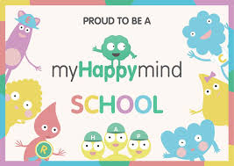
We have started our new PSHE curriculum ‘Our Happy Minds’. It is a NHS approved programme that prepares today's children for tomorrow's world by building resilient, balanced and happy minds. We aim to create a culture of positive mental wellbeing!

Teaching Assistants
Mrs Rimmer will be working as a Teaching Assistant in our class Monday to Friday.

Water Bottles
Please ensure your child has a named water bottle in school. These will be sent home each week for washing and refilling.

Health Care Plans
If your child has a health care plan, any allergies or special requirements please ensure they are up to date with the office. All medicines/inhalers have been checked and most were unfortunately out of date when passed up from Mrs Short last term so please check these! Thanks!

We have a ‘Meet the Teacher’ session afterschool on Monday 8th September from 3:30 – 4:30 if you would like to pop and meet me, have a chat or ask any questions!

If you have any questions, worries or concerns please ring the office and leave a message, or make a note in your child’s reading diary. I will get back to you as soon as possible.

As always I will be available at home time for a chat at the gates if you need me!

Many thanks for your continued support.
We look forward to an exciting and fun filled year!

Miss Watson
&
Mrs Rimmer

